2017 AGM Business
OMA COUNCIL NOMINATIONS 2017/2018
The Nominations Committee, composed of Chair, OMA President, Clark Bernat (City of Niagara Falls Museums), OMA Vice President Petal Furness (Grey Roots Museum & Archives), and the three members elected by the membership at the 2016 Annual General Meeting in Mississauga, Ontario, Ian Kerr-Wilson (City of Hamilton Museums), Madeline Smolarz (Ruthven Park National Historic Site), Amber Lloydlangston (Museum London) is pleased to bring forward the following slate of Council nominations for election by the membership at the 2017 Annual General Meeting, Friday, October 13 at Four Points by Sheraton.

The responsibility to select candidates best suited to lead the Association requires thoughtful planning and attention to skills / areas of expertise currently required by the Council for its Strategic Plan implementation; therefore the OMA adheres to the practice of not accepting nominations from the floor at the Annual General Meeting.

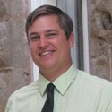
CLARK BERNAT, PAST PRESIDENT
FIRST YEAR OF A TWO-YEAR TERM
Born in St. Catharines, Clark developed a great appreciation for museums due to his many visits to cultural institutions with his grandfather and parents. Clark has a degree in History from Brock University and a Master's Degree in Museum Studies from the University of Leicester. His work at Leicester focused on cultural diversity in museums. Clark has worked in various capacities at the St. Catharines Museum, Battlefield House Museum, Backus Heritage Village and the Niagara Historical Society Museum; currently he is the Culture & Museums Manager for the City of Niagara Falls Museums. He has sat on the Steering Committee of the Children's Discovery Centre of Niagara, chaired Doors Open Niagara and the Museums of Niagara Association (MONA).

“I look forward to serving the museum community of Ontario on the OMA Council. As a director of a mid-sized museum I understand the diversity of needs of our sector. I would like to provide my experience and expertise in community building, partnerships, advocacy and public relations to Council and our community.”
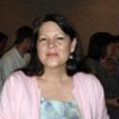
PETAL FURNESS, PRESIDENT
FIRST YEAR OF A FIRST TWO-YEAR TERM

Petal Furness, Manager of Grey Roots Museum & Archives, located in beautiful Grey County, leads an inspirational team of museum professionals and volunteers. She has been a part of the Grey Roots team since 2004. Petal became a Heritage Interpretation advocate while employed as a summer student at Fort Langley N.H.S. Petal moved to Calgary Alberta to pursue her interpretation passion and there she held positions of Historic Site Interpretation Specialist, Aboriginal Liaison and Service Planner. Born and raised on the West Coast, Petal is proud of her Aboriginal roots and provides cross cultural presentations to increase understanding and forge positive relationships. She is an active volunteer in her community, an advocate for green living and Petal’s greatest joy is her ever expanding family.

“I have had the experience of being on council for two terms and appreciate the opportunity of working with other dedicated and talented volunteer board members. This has been a busy yet rewarding year as the OMA prepares for our cultural future with our 2025 Strategic Plan. And, as I say every year, our OMA staff are amazing to work with and represent cutting edge knowledge within the museum field.”

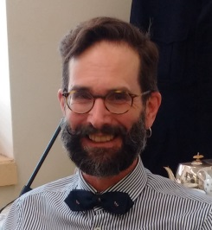
PAUL ROBERTSON, VICE PRESIDENT
FIRST YEAR OF A FIRST TWO-YEAR TERM

Paul Robertson became the City of Kingston’s first City Curator in 2011. He holds degrees in journalism and Canadian history. A material history specialist and social historian for the past 25 years, Paul learned his trade working with different federal collections in Ottawa, including those at the Canadian Museum of Civilization (now the Canadian Museum of History). He is the former curator at the Museum of Health Care at Kingston. Paul’s currently leads the curatorial team in the historical interpretation the City’s civic collection, two municipal museums and historic City Hall, and acts as a liaison with the Kingston museum and heritage sector. Paul seeks to build stronger working connections between museums that help all institutions to meet their mandates and the needs of our communities more effectively.

“Ontario has a rich tapestry of museums and historic sites – without them, we would be significantly diminished. Museums
today face a growing opportunity to reflect and respond to the changing face of Ontario in a way that is diverse and inclusive of all residents. I was honoured to serve on the Looking Ahead task force that resulted in Ontario’s Museums 2025 and I look forward to helping to make its vision a reality. As an OMA councillor, I hope my experience working in the cultural heritage sector at the national and local levels can benefit the Ontario museum community.”

CATHY MOLLOY, TREASURER
FIRST YEAR OF A FIRST TWO-YEAR TERM

Cathy Molloy is the Director of Markham Museum. Working in the most demographically diverse city in Canada, Markham Museum has developed a program direction where the entire community feels welcome. Through the examination of basic human technologies that we have in common, Markham Museum creates a shared understanding of our past and present day. Cathy’s educational background is a mix of archaeology and accounting, with work experience in both the corporate and museum world.

“Although we have come a very long way, Museums still struggle to validate their relevance to their community. Many government and business leaders recognize the benefits that Museums bring to quality of life and economic development. However, we need to continue to work with our stakeholders to ensure we stay connected to our communities. The OMA is a venue to help all Ontario museums learn and develop, and help us continue the good work that we all do. I look forward to working with the OMA and the larger Museum community.”

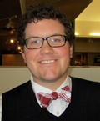
BRADEN MURRAY, SECRETARY
FIRST YEAR OF A FIRST TWO-YEAR TERM

Braden Murray is the Museum Educator at the Lake of the Woods Museum in Kenora. He has been in the museum field since 2008, and has previously held positions at the Beaverbrook Art Gallery and Kings Landing Historical Settlement. Braden has a degree in History from the University of New Brunswick, and a Masters in Public History from Western University. He is interested in getting young people involved in museums, public engagement, cultural resources management, and uses of technology in museums.

“The Ontario Museum Association is the provincial leader in the museum sector, and plays a vital role in capacity building, professional development, and advocacy. I consider it a privilege to be a small part of the OMA body, and look forward to working with the OMA Council and our partners to ensure a relevant, sustainable, and vibrant museum sector.”
helping to make its vision a reality. As an OMA councillor, I hope my experience working in the cultural heritage sector at the national and local levels can benefit the Ontario museum community.

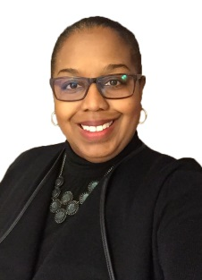
CHERYL BLACKMAN, COUNCILLOR
FIRST YEAR OF A FIRST TWO-YEAR TERM

Cheryl is Assistant Vice-President, Audience Development at the Royal Ontario Museum (ROM). Her responsibilities include ensuring a quality experience for the front of house, and diversity and inclusion for the museum. Cheryl is the main point of contact for more than 1300 volunteers, and she leads the ROM's Community Access Network (ROMCAN) which she created and has grown into more than 60 partnerships with organizations across the GTHA. Cheryl’s leadership and commitment to inclusion has grown this area into a highly successful part of the ROM where the Museum regularly achieves high satisfaction levels amongst visitors, and wins awards for innovation in all aspects of access and community building. Cheryl holds a Bachelor of Social Work (BSW), and a Master of Business Administration (MBA), and is a Fellow of Inclusion and Philanthropy from the Association of Fundraising Professionals (AFP). She has also served as a member of the 2017 Fundraising Day planning committee. She is the Incoming Vice Chair at the Robert McLaughlin Gallery and an Officer of the Diversity committee at the American Alliance of Museums.

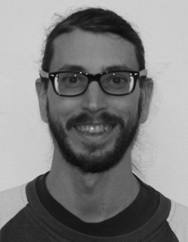
NATHAN ETHERINGTON, COUNCILLOR
SECOND YEAR OF A FIRST TWO-YEAR TERM

Nathan Etherington received a Bachelor of Science degree from the University of Waterloo with minors in Earth Science and Geography. He subsequently attended Western University for a Bachelor in Education focusing on equity and social justice issues in education. With both of these experiences, he entered the museum sector as a Young Canada Works student focusing on adult education programming. He then started as a volunteer with the Brant Historical Society before being offered the position of Program Coordinator. Since May 2015, he has taken a more active role overseeing the day-to-day operations for the Brant Museum and Archives location.

“Working within the museum sector since 2012, I have witnessed the great work and support provided by the OMA. Finding a voice within the OMA for small, community museums with limited staff and finances is one of the interests that I bring to Council. As an emerging professional, I will work to enhance the professional development program offered by the OMA and further my own professional development by serving on Council. The third area of interest I have is a liaising with other museums to hear concerns, suggest solutions to these issues, and increasing collaboration within the sector.”

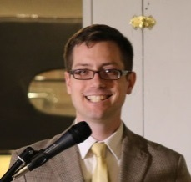
ALEXANDER GATES, COUNCILLOR
FIRST YEAR OF A FIRST TWO-YEAR TERM

Alexander Gates has served as the Executive Director and Curator of the Canadian Automotive Museum since 2014. Originally from the United States, he previously worked as the Executive Director and Curator of the North Berrien Historical Museum in Coloma, Michigan. Alex holds a B.A. in International Relations from Drake University, a Masters of Museums Studies degree from the University of Toronto, and studied French at the Sorbonne in Paris while working as a guide on the Eiffel Tour. As one of Canada’s only automotive curators, Alex represents Canadian heritage around the world, working with international partners to tell Canada’s unique car stories, while also serving as a local community partner in the redevelopment of downtown Oshawa.

“My interest in this position is driven by a passion to strengthen the museum community through advocacy and collegiality, In particular I am an advocate for transportation museums, which are undervalued and underfunded by the Province of Ontario, despite their popularity with the public. As a museum professional that has worked in both the United States and Canada I look forward to bringing my experience to the OMA and demonstrating to government officials that museums are a vital part of society and not an easily reduced budget item.”

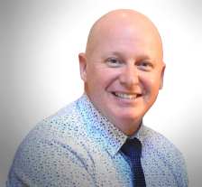
FRASER MCDONALD, COUNCILLOR
FIRST YEAR OF A FIRST TWO-YEAR TERM

Fraser manages the Business Operations for three national museums all located in Ottawa. Fraser is all about generating non-stop ideas, maximizing social media and new media, and running the best museum Membership Program, gift shops, and Customer Relations Team in the country. After combining Membership, Commercial Operations, and a full Customer Relations Team, he has the privilege to oversee a new dynamic Business Operations unit, responsible for generating revenue, attendance, and delivering exceptional customer service along the way. Previous roles include Manager, Membership, Assistant Manager, Commercial Operations, and I have remained involved with the Foundation that supports the museums since its inception. His specialties include business development in non-profit environments, on- and off- line marketing, email marketing, event planning and coordination, all bound together with the benefits of social media.

“My primary interest lies in helping deliver the mission of the Ontario Museum Association, especially in terms of facilitating excellence and best practices, and in improving the communication and collaboration of its membership. Through my experience as co-founder of Canada's largest museum-centric social club, Drinking About Museums Ottawa-Gatineau; as an alumnus of the Getty Leadership Institute's NextGen Canada program; and through sitting on various committees at my workplace, Ingenium – Canada's Museums of Science and Innovation, I believe I have much to offer, and would be honoured to do so.”
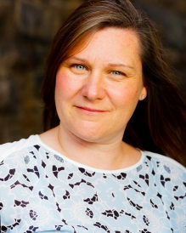
SONIA MRVA, COUNCILLOR
SECOND YEAR OF A FIRST TWO-YEAR TERM

Sonia is responsible for the management of cultural heritage resources for the City of Hamilton. Her most recent work includes the Downtown Built Heritage Inventory Project, a cross departmental initiative between the Heritage Resource Management section and Cultural Heritage Planning. This project was a departure from traditional built heritage inventories through its inclusion of the community in developing an understanding of the value placed on heritage resources. Sonia believes that the inclusion of community is critical in developing a better understanding of the role Museums plays in our society. Prior to her current position, Sonia held Curatorial positions at both Whitehern Historic House and Garden and Dundurn National Historic Site. Sonia has a Bachelor of Arts, History with post graduate work in Museum Studies, Cultural Management and Leadership.

“Increasingly, communities are recognising heritage as having both social and cultural capital. Our Museums enhance communities by providing a tangible connection to the past and emphasizing a community’s identity and sense of self while encouraging community cohesion. By better understanding the role which museums play in society and the value derived from a “visit”, we can better position our institutions for the future. The OMA is a venue which encourages these ideas of sustainability and encourages development in our field through shared learning. I look forward to connecting with colleagues across the Province through the OMA Council.”
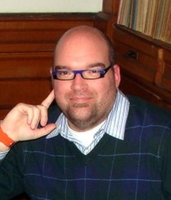
MICHAEL RIKLEY-LANCASTER, COUNCILLOR
FIRST YEAR OF A FIRST TWO-YEAR TERM

Born and raised in Chatham Ontario, Michael has been Executive Director/Curator of the Mississippi Valley Textile Museum since July 1, 2007. He studied Fine Arts at Fanshawe College in London Ontario, before receiving a diploma in Applied Museum Studies from Algonquin College in Ottawa. He was employed as Assistant Curator at the Diefenbunker, Canada's Cold War Museum, and then Program Coordinator for Young Canada Works in Heritage Organizations with the Canadian Museums Association. He has served on the Council of Heritage Organizations Ottawa, as well as the Lanark County Tourism Association board of directors. He currently sits on the Arts & Cultural Advisory Committee, Heritage Committee, Downtown Almonte Heritage District Study Committee, River Walk Committee and the Festivals Committee for the Town of Mississippi Mills and is part of the Lanark County Museum Network. Michael also sits on the Community Heritage Ontario Board of Directors, the Ontario Museum Associations conference planning committee and the Ontario Historical Societies, Museums Advisory Committee. Michael is the 2014 Cultural Achievement Award winner for the Young Award within the Municipality of Mississippi Mills.

“From my experience of being on the OMA’s “Looking Ahead” Steering Committee and the 2017 Conference Planning Committee, I have gained insight into the way forward for Ontario museums. With 15 years of experience working in the field, mostly in a small-town museum setting, I would like to give insight into the challenges of small museums. A primary interest is to work on a committee to assess operational funding for small museums in Ontario, specifically to reassess (increase) CMOG funding for museums that meet CMOG standards, and to explore the application of the municipal library funding model to Ontario museums.”

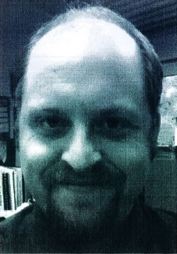
SEAN STOUGHTON, COUNCILLOR
FIRST YEAR OF A FIRST TWO-YEAR TERM

Originally from Holland Landing, Ontario, Sean is a graduate of Western University with a Combined Honours Degree in History and Anthropology. Starting as a volunteer excavator at the Museum of Ontario Archaeology, Sean has since worked as an interpreter at Black Creek Pioneer Village in Toronto and the Waterloo Region Museum in Kitchener. He is currently the Village Coordinator with the Waterloo Region Museum. Sean is also a graduate of the Ontario Museum Association’s Certificate in Museum Studies program, and a member of the OMA since 2009. Always interested in material culture, Sean has a continuing fascination with historic trades and industries, as well as the archeology of tool making and technology. Sean is an avid blacksmith, and is currently the Vice President of the Ontario Artist Blacksmith Association. He lives in Kitchener with his wife Heather and their countless pets.

“I have been a member of the Ontario Museum Association since 2009, and have participated in conferences, committees, and the CMS program. I have gained a great deal from my involvement with the OMA. In particular, I would like the opportunity to help the OMA in it is efforts to address the issues and challenges facing Ontario’s municipal and living history museums, and to support the goals of the Ontario’s Museums 2025 Strategic Vision and Action Plan.”

