ICOM‐Canada
The International Council of Museums (ICOM) is an international organization of museums and museum professionals, which is committed to the conservation, continuation and communication to society of the world's natural and cultural heritage, present and future, tangible and intangible.
ICOM Canada is the Canadian national committee of ICOM. We are a dedicated group of professionals, who are passionate about museums and international networking.
ICOM‐Canada Travel Bursary
To help emergent museum professionals in building networks and lasting connections, ICOM Canada provides an annual Travel Bursary to support the participation of a graduate student or an emergent museum professional (with less than 5 years of work experience) to the annual ICOM conference or to any meeting of ICOM’s international committees.
ICOM‐Canada will provide up to $1,500 to cover costs related to conference registration, travel, accommodation, and local transportation, as well as a per diem allowance for meals. It is expected that applicants will seek additional funding through their university or employer. The bursary will be awarded by an adjudication committee formed by the board of ICOM Canada.
Note: The award can be used to cover costs for either virtual or physical attendance.
Eligibility
- The applicant must be:
  - a Canadian citizen or resident, and;
  - A student enrolled in a graduate program in an accredited university (Canada or abroad) or an emerging museum professional with less than 5 years of work experience.
  - We welcome applications from students in diverse disciplines addressing issues related to museology, including, but not limited to, intercultural museology, museums and the Web, information technologies, collections management, museum administration, intangible heritage.
- Individuals are only able to receive one ICOM Canada Travel bursary in their lifetimes, but may reapply if unsuccessful.

Application Procedures
Applications may be submitted in English or in French. All application materials should be completed in 12-point font with minimum 2.5 cm page margins. Applications should include:
- A completed application form.
- A brief (maximum two‐page) curriculum vitae.
- A brief (maximum 250 words) statement of purpose. It should provide a brief overview of your museological interests and professional aspirations.
- A budget, including estimates for conference registration, return economy transportation, accommodation in the most economical residence, $50 per diem rate to cover meals over the duration of the conference/meeting.
- A letter of reference from a faculty supervisor or work supervisor.
Application Deadline
The deadline for applications is March 15, 2022. Applications should be emailed as a single attachment to Michele Rivet, ICOM Canada board member at michele.rivet2010@gmail.com.
The successful applicant will be reimbursed for expenses upon submission of the following:
- A statement of expenses with appropriate receipts; and
- A two‐page conference report (to be posted on the ICOM‐Canada website).
Questions? Contact: Michele Rivet, ICOM Canada, michele.rivet2010@gmail.com

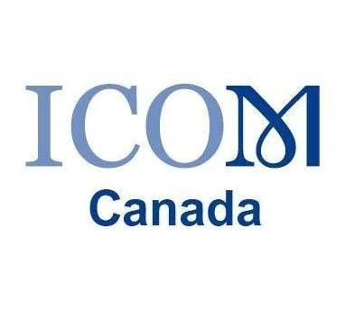
ICOM-Canada Travel Bursary Application Form

Name:
Mailing Address:
Email:
Telephone:
Home Department and Institution:
Referee Name & Email:
Accompanying Documentation:
☐ A brief (maximum 250 words) statement of purpose
☐ 2-page CV
☐ Reference Letter
☐ Budget

