[YOUR LETTERHEAD]

[Mayor’s Mailing Address] [DATE]

Dear Mayor XXXXXX,
On behalf of [Museum Name] and in collaboration with the Ontario Museum Association, I am writing to request a Municipal Proclamation of May is Museum Month/Mai, Mois des Musées in [Community Name].
The start of the summer tourism season, May is Museum Month provides an excellent opportunity for the promotion and awareness of Ontario’s exceptional museums. During May is Museum Month/Mai, Mois des Musées we encourage everyone to explore and experience local museums, joining the 19.4 million visits welcomed by Ontario museums every year.
Celebrated annually since 2000, May is Museum Month/Mai, Mois des Musées is a program of the Ontario Museum Association and celebrated by Ontario’s 700+ museums, galleries, and heritage sites. May is Museum Month coincides with International Museum Day on May 18th, a worldwide initiative of the International Council of Museums to highlight the importance of the role of museums to create meaningful experiences for peoples of all origins and backgrounds. Museums, galleries, and heritage sites help create distinct and vibrant places to live, work, visit, and invest!
Mayors and communities across the province will proclaim May is Museum Month, and we would be honoured if [community name] joined them in recognising value of museums, galleries, and heritage sites to our communities.
Please find a draft Proclamation attached.
If you or any members of your staff have any questions, please reach out to me by phone [your phone number] or email [your email]. [Museum Name] and the Ontario Museum Association look forward to celebrating May is Museum Month/ Mai, Mois des Musées!
Sincerely,

[YOUR NAME]
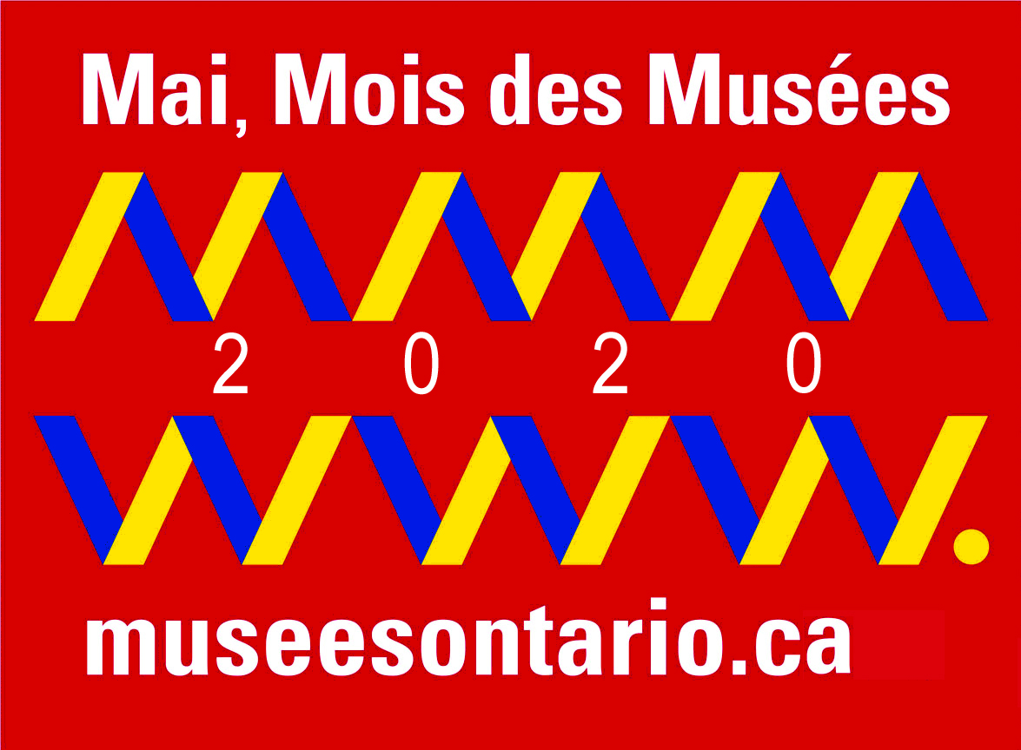
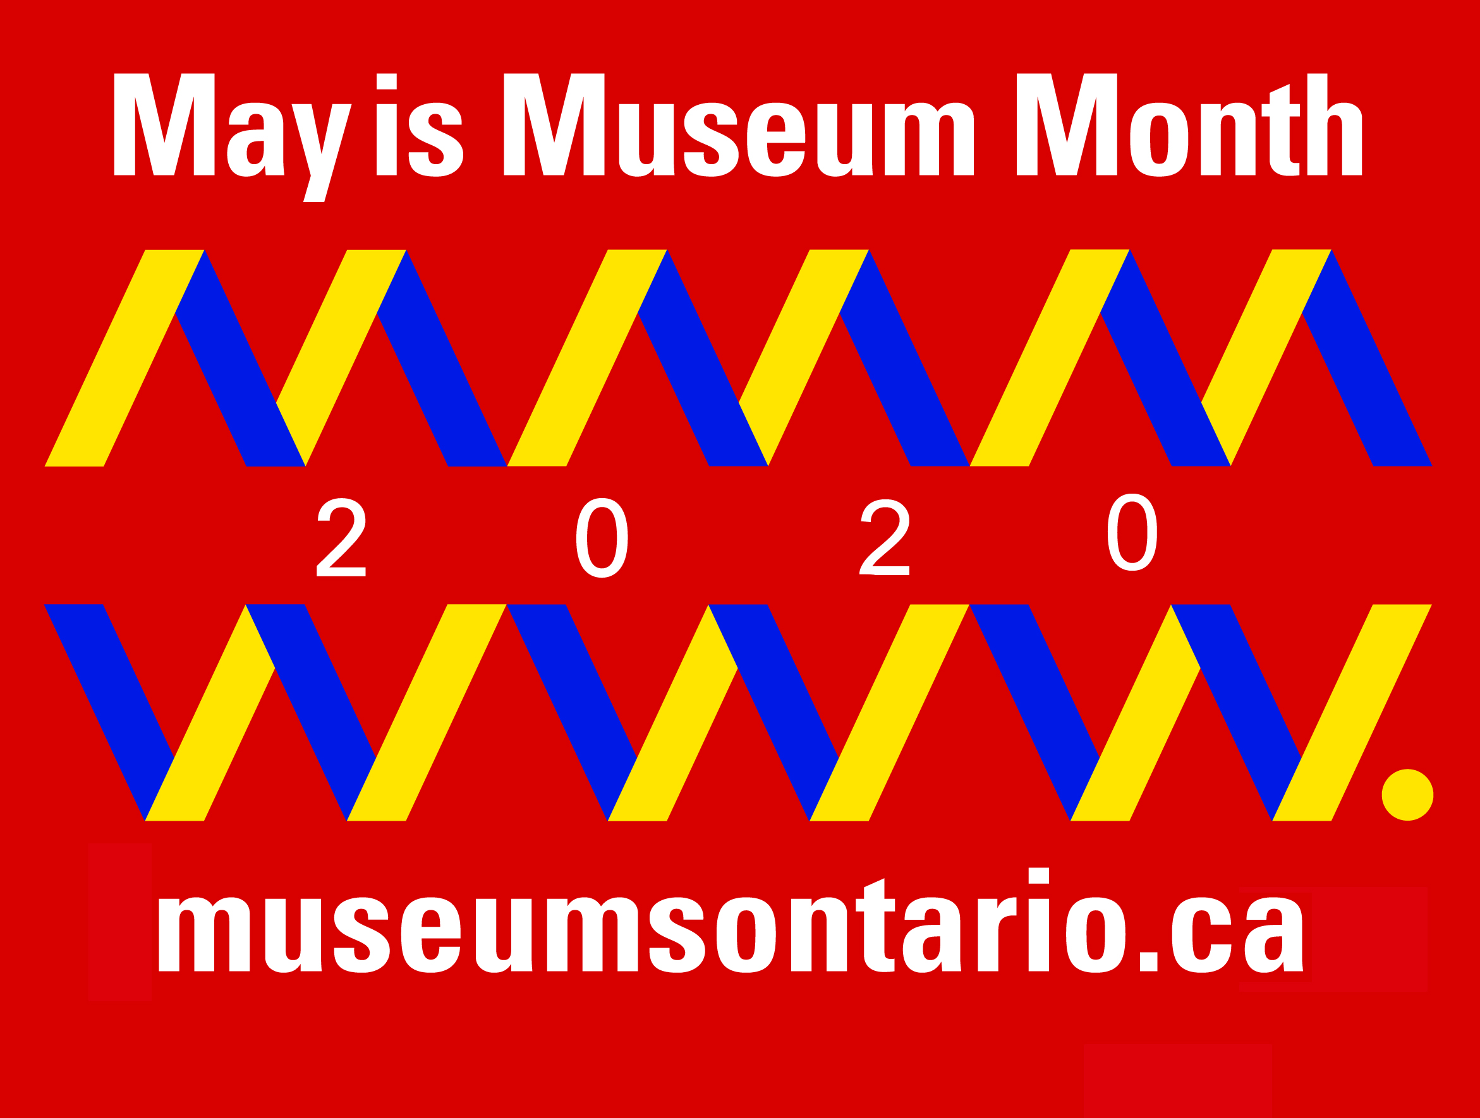
[YOUR INSTITUTION]

