Canadian Heritage Funding Portal
Museums Assistance Program

User Guide: A Step-by-step guide to submitting your application

Home 2
Before You Begin 4
Organization Information 5
General Information 8
Project Information 12
Official Languages 15
Community Engagement 19
Project Planning 22
Project Detail 24
Project Budget 28
Organizational Capacity 30
Supporting Documents 32
Additional Documents 34
Museum Requirements (*only for museums) 36
Declaration/Attestation 38
Final Review 39

Home
TIP: The recommended browser to access the Canadian Heritage Funding Portal is the latest version of Google Chrome, Firefox, Microsoft Edge or Safari. Internet Explorer is not a supported browser.

On the homepage of the Canadian Heritage Funding Portal, there will be a list of Quick Actions.

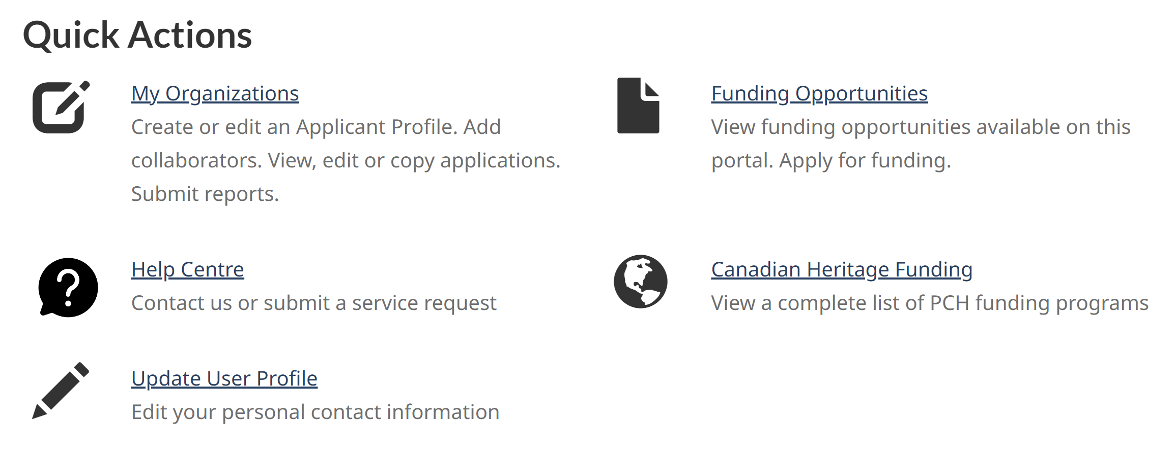

Click on Funding Opportunities to view funding opportunities available through the portal. Please note your Applicant Profile must have been completed in order to proceed.

This will bring you to the Funding Opportunities page. At the bottom, there will be multiple program/component tiles to choose from.
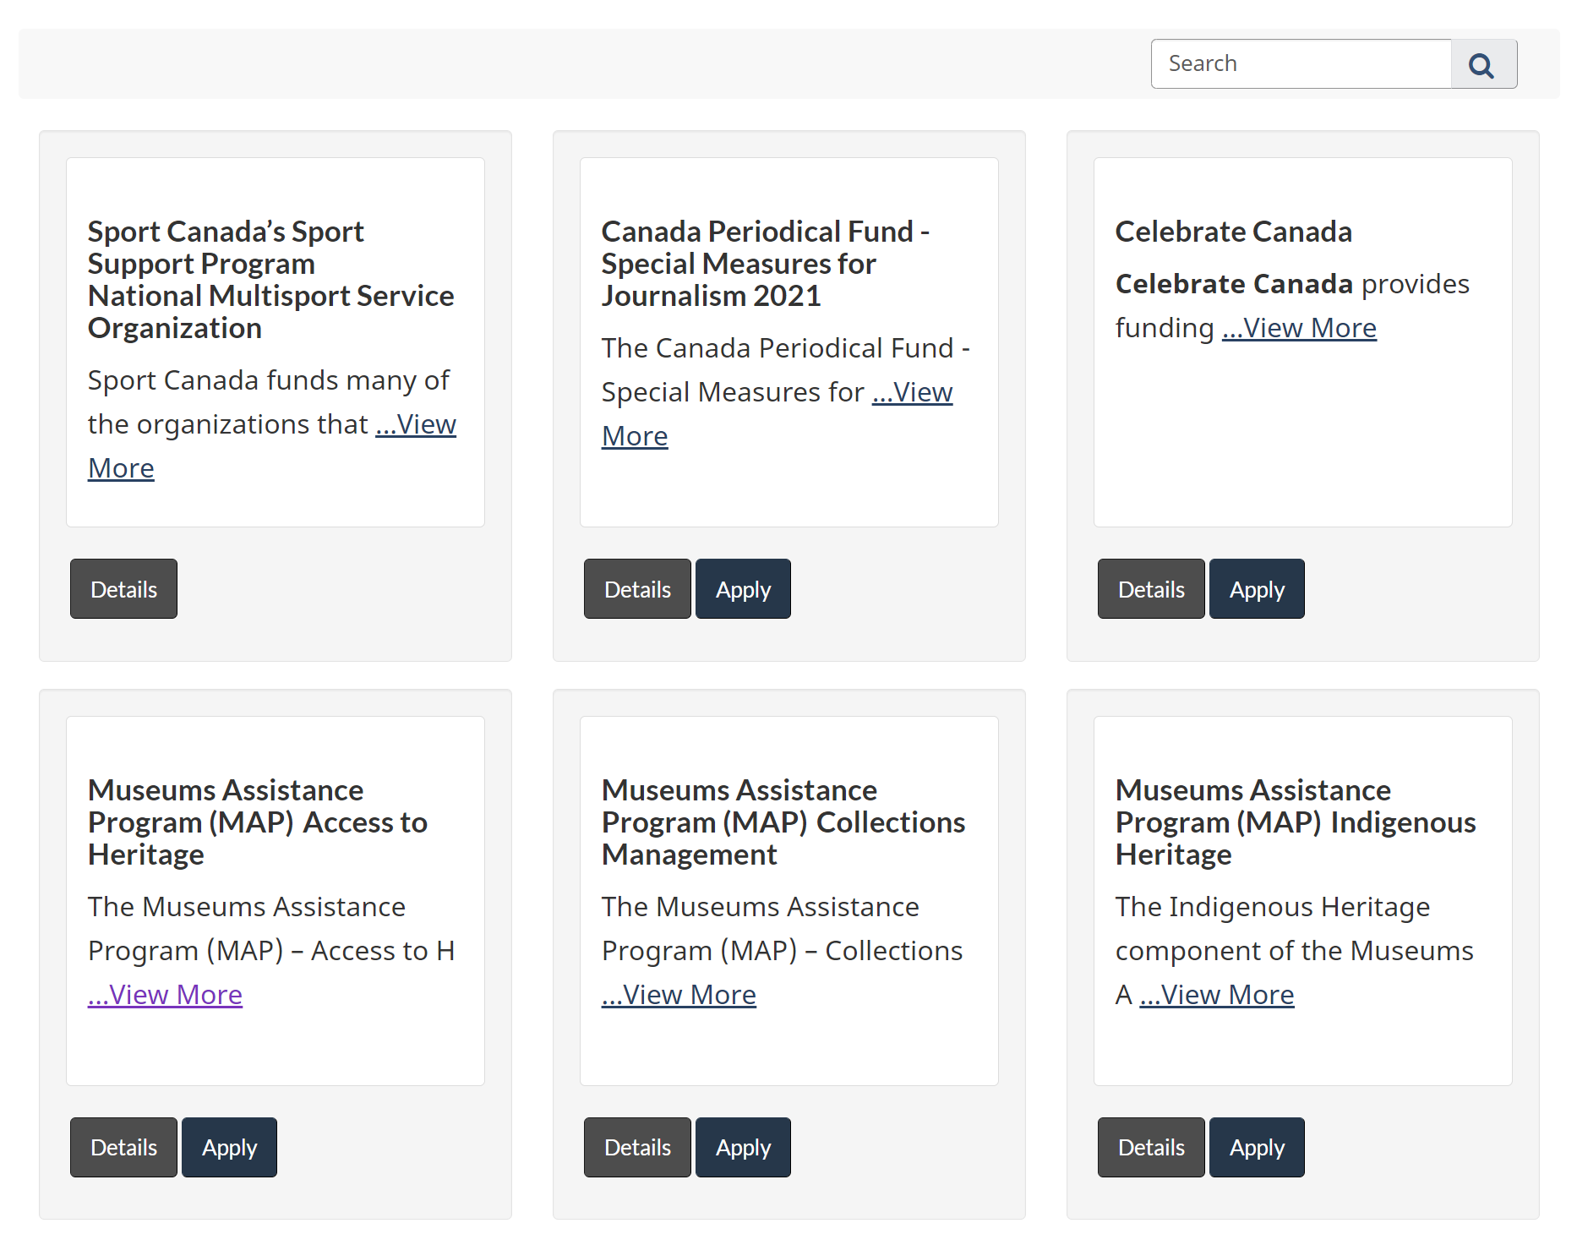

Use the navigation buttons to look through all of the available funding opportunities, or use the search bar to find the exact component you would like to apply for (e.g. Access to Heritage).

The Details button will pull up a description of the program and component, along with an Apply button.

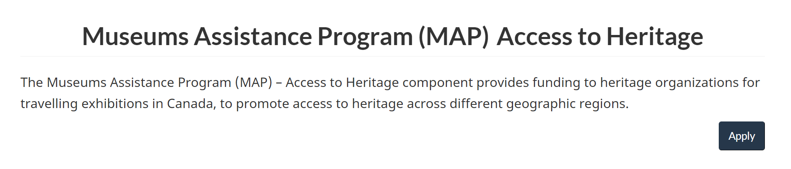

The Apply button will bring you directly to the start of the application.

Before You Begin

Read through the Before You Begin section, which provides more details about the funding opportunity, as well as the application process and certain eligibility criteria.

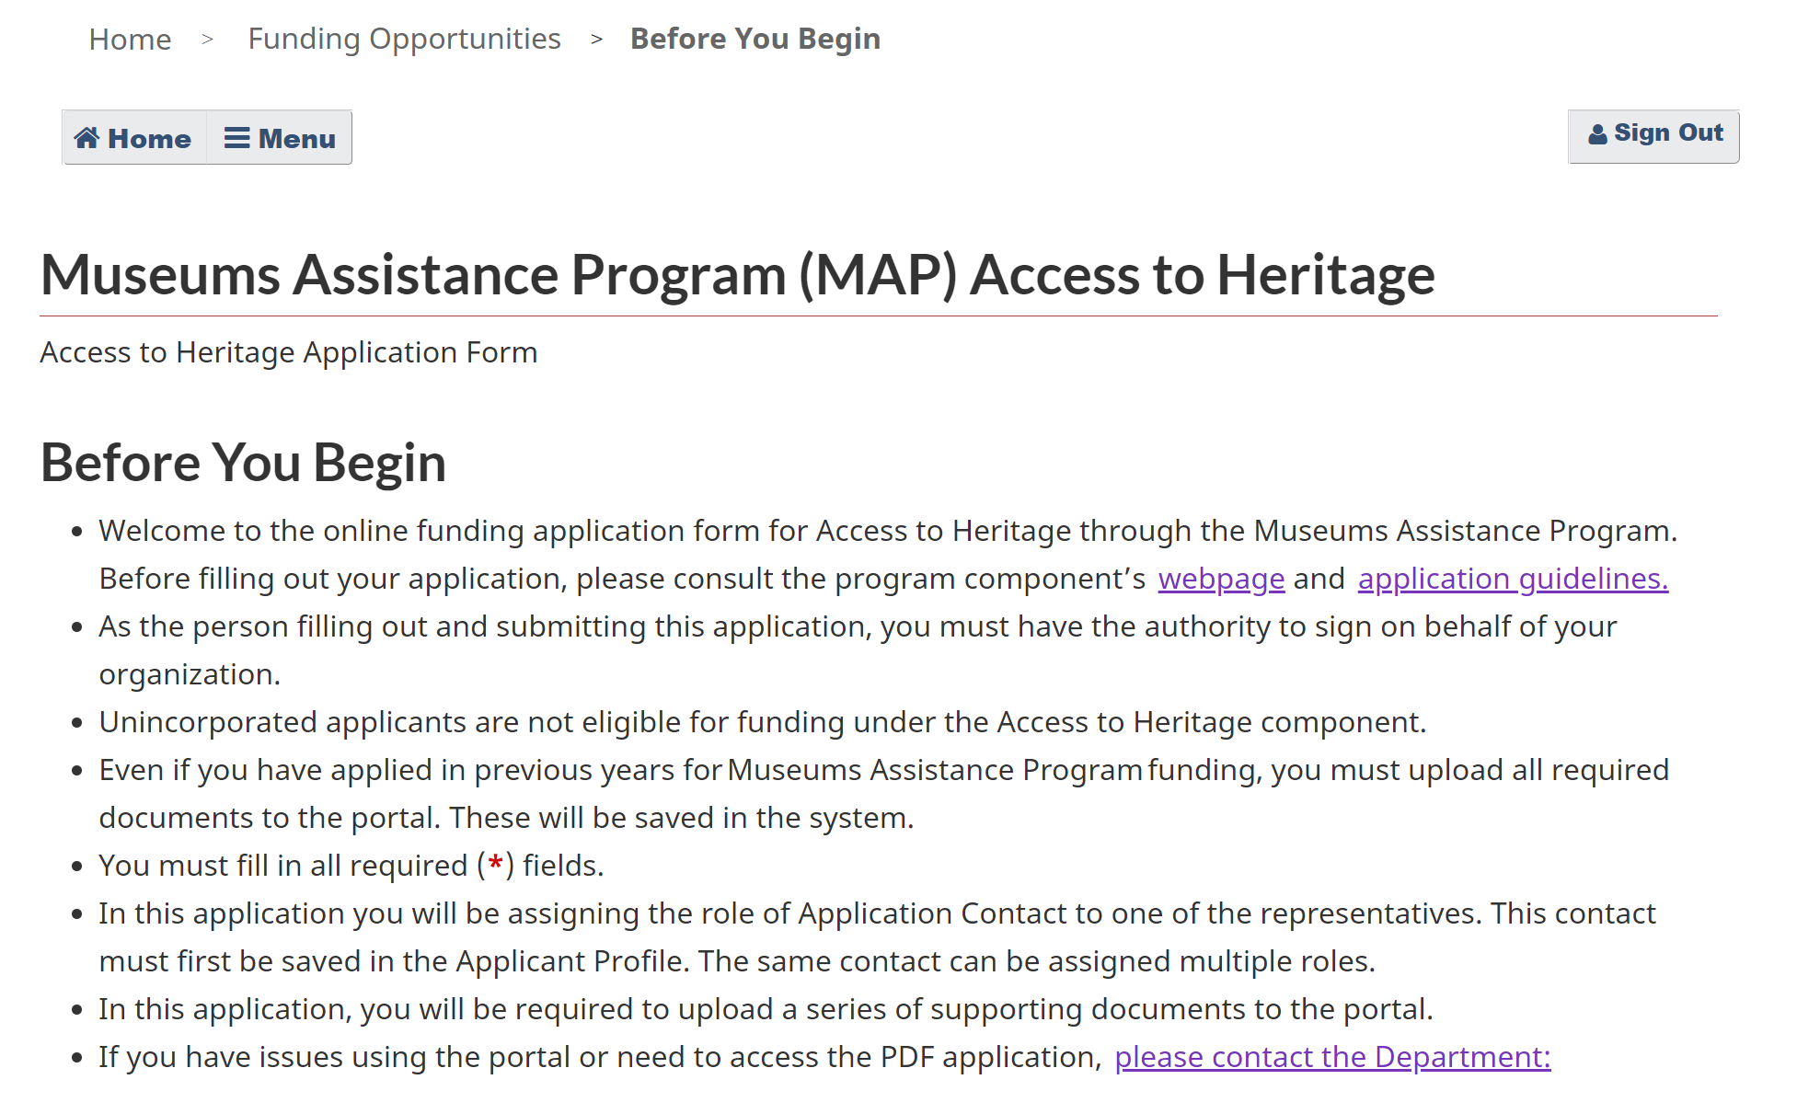

Click the Start Application button at the bottom.

Organization Information

Under Organization, select the organization that will be applying for funding. You will be able to choose from any of the organizations that you registered under “My Organizations.”

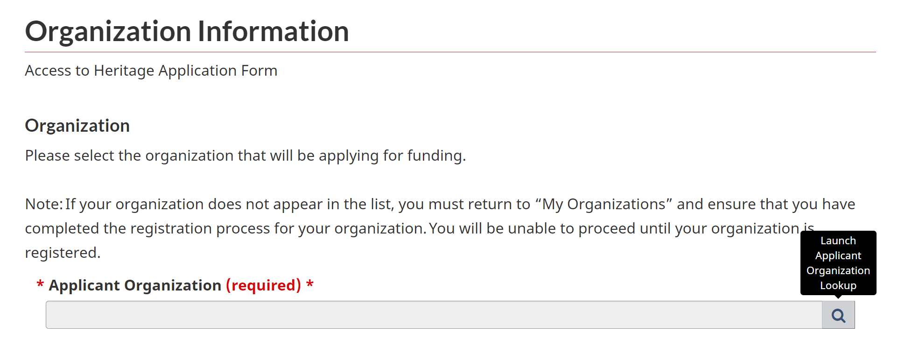

Click the Search/magnifying glass icon.
In the pop-up window, choose the organization that will be applying for funding. Click Select.

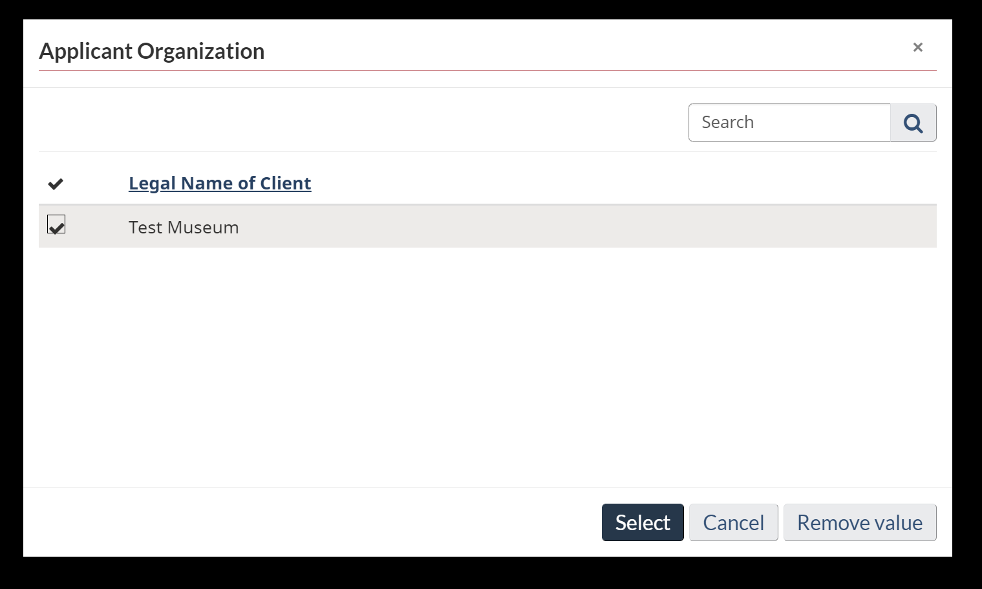

Under Roles, assign the role of Authorized Representative to one of the representatives identified in your Applicant Profile.

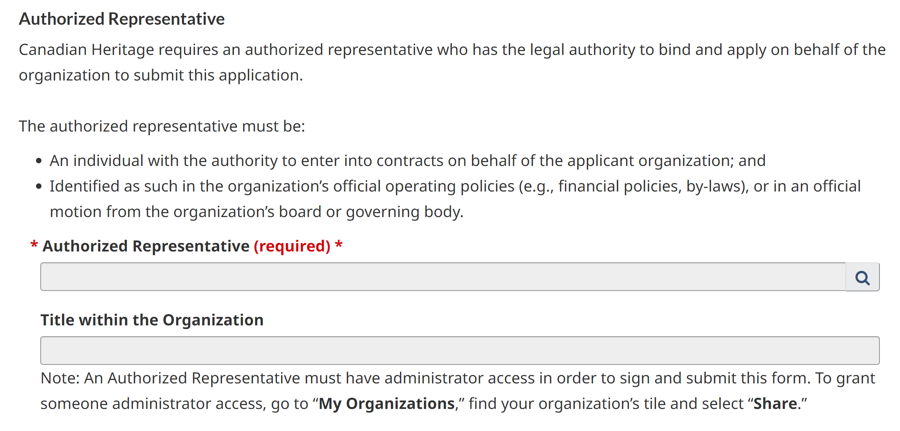

Click the Search/magnifying glass icon.

In the pop-up window, choose the person who will be the Authorized Representative. Click Select.

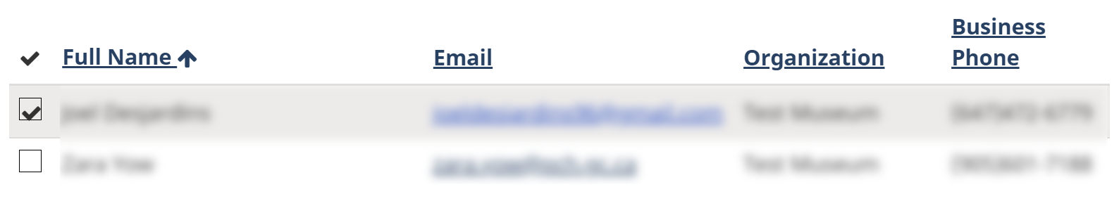

Assign the role of Application Contact to one of the representatives identified in your Applicant Profile.

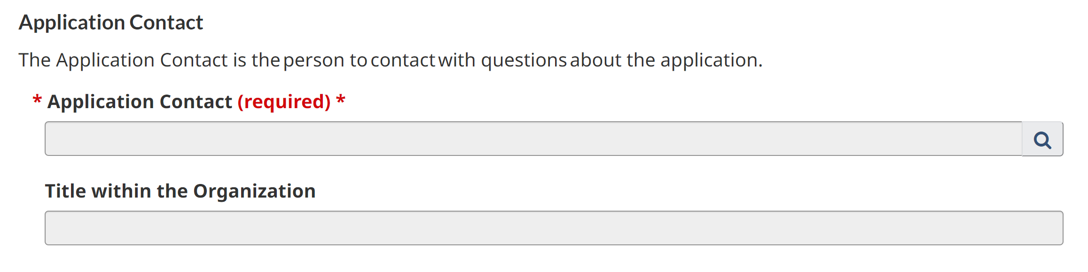

Click the Search/magnifying glass icon.

In the pop-up window, choose the person who will be the Application Contact. Click Select.

Click the green Save button at the bottom of the screen.

Once the page has refreshed, scroll down and click Next.

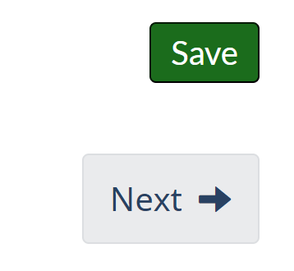

General Information

Choose either Yes or No from the dropdown menu to indicate if your organization belongs to an Indigenous community or is an Indigenous-controlled organization.

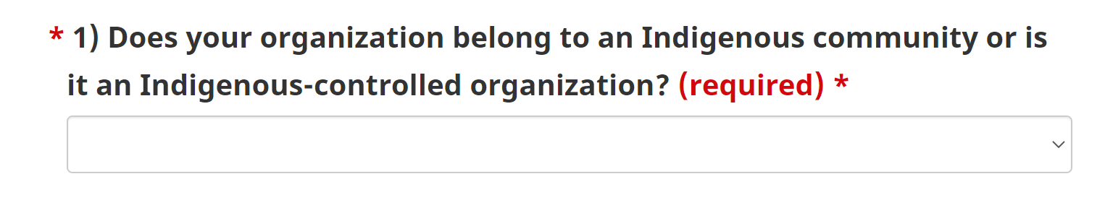

If Yes, please specify by selecting First Nations, Inuit, Métis, or Other (please specify).

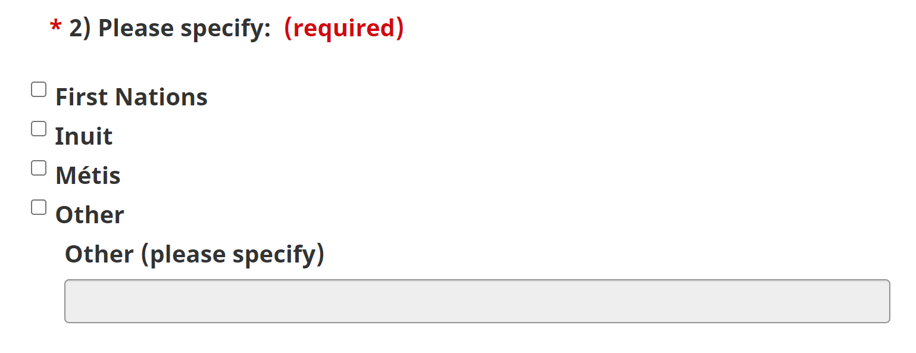

Choose either Yes or No from the dropdown menu if your organization belongs to an ethnocultural and/or racialized community. Definitions are listed below the question.

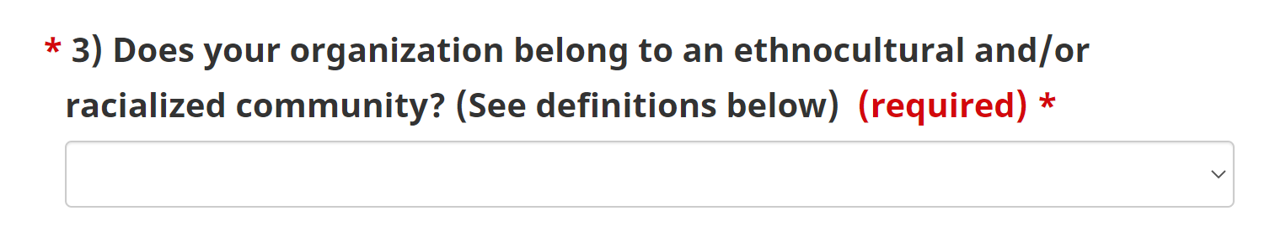

If Yes, please specify.

Choose either Yes or No from the dropdown menu if your organization belongs to another underserved community (LGBTQ2+, youth, etc.).

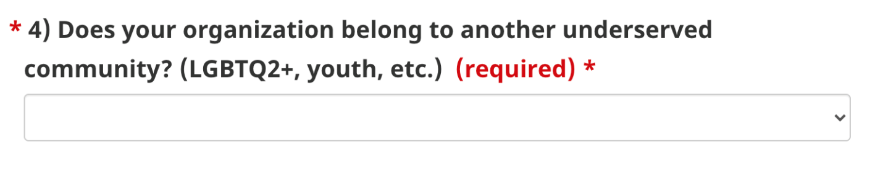

If Yes, please specify.

Choose Rural, Remote or N/A from the dropdown menu if your organization is located in a rural or remote area.

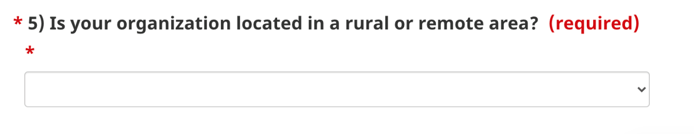

Under Organization Type, indicate your organization type from the provided checklist. You may only indicate one organization type.
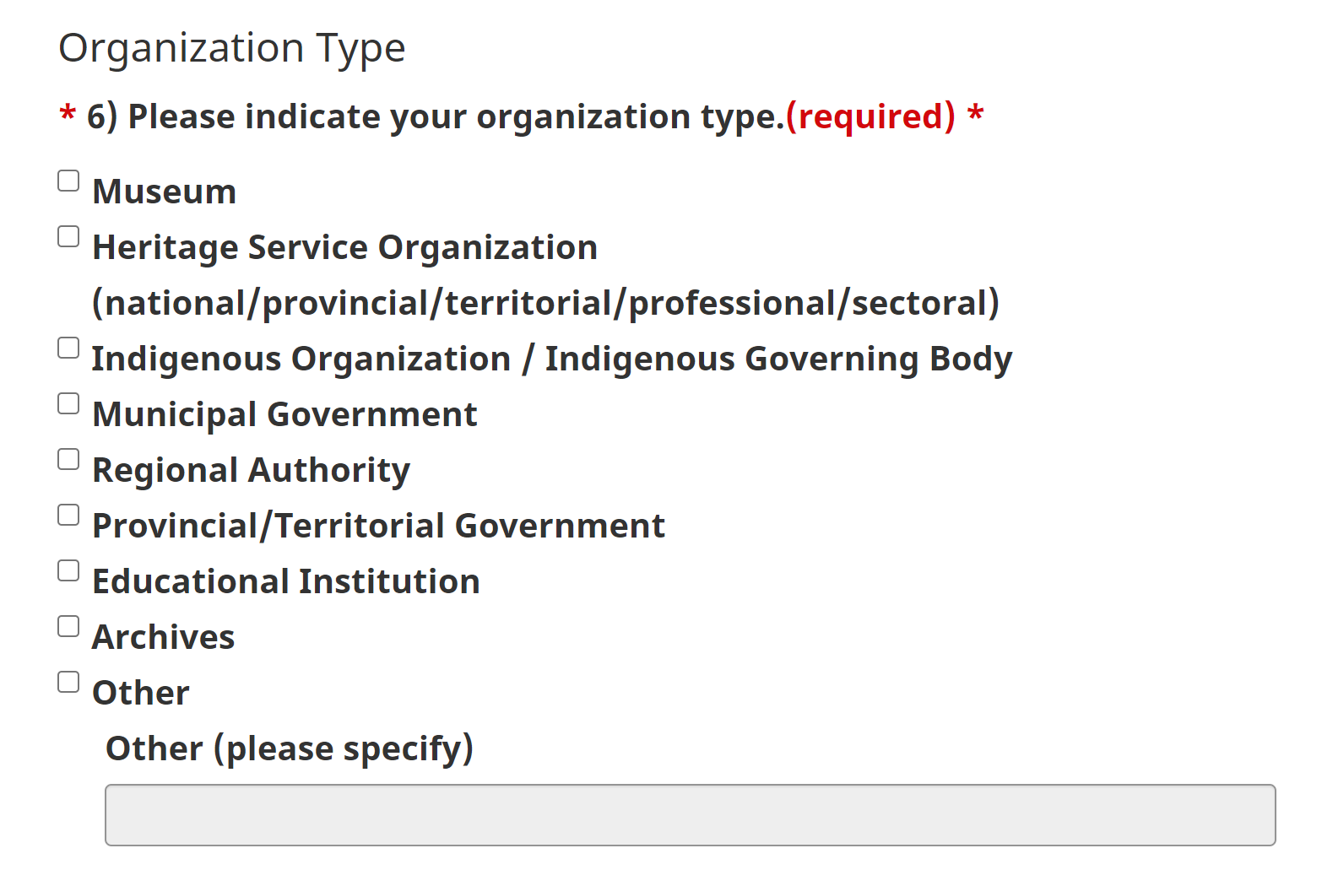

Under Staff, enter the number of staff for each category (Full-time paid, Part-time paid, Full-time volunteer, Part-time volunteer). You must have a value for at least one of the categories in questions 7–10.

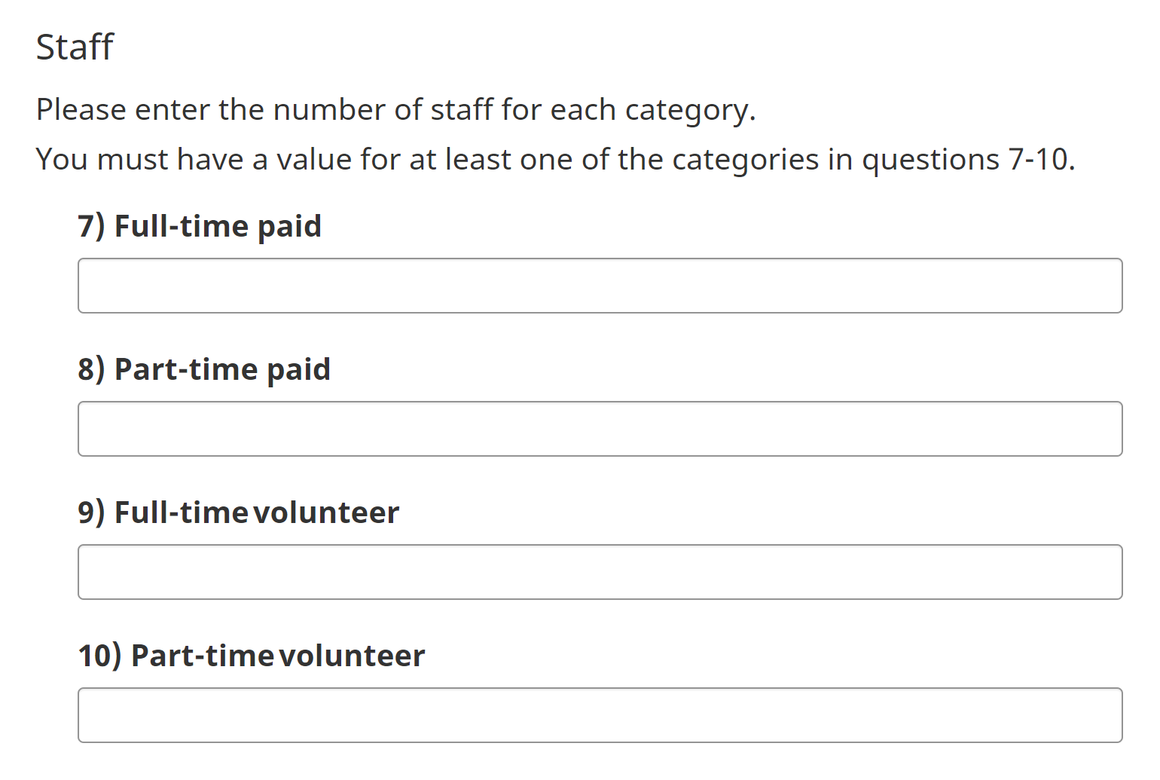

Under Attendance, enter the number of attendees for each category (Visitors per year, External users per year).

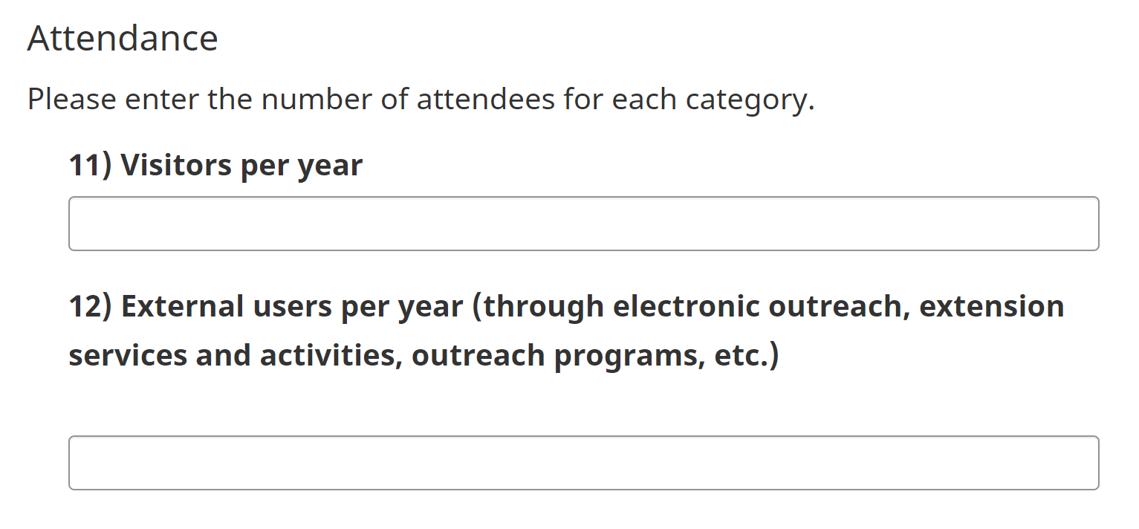

Click the green Save button at the bottom of the screen to save your progress.

If successful, once the page has refreshed, there will be a green Saved box at the top of the screen. Scroll down and click Next.

Project Information

Choose either Yes or No from the dropdown menu if your organization is working on ongoing PCH funded projects.

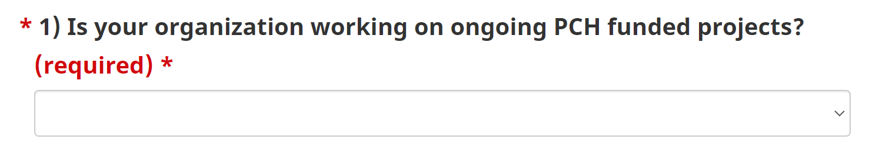

If Yes, please describe how your organization will manage multiple projects.

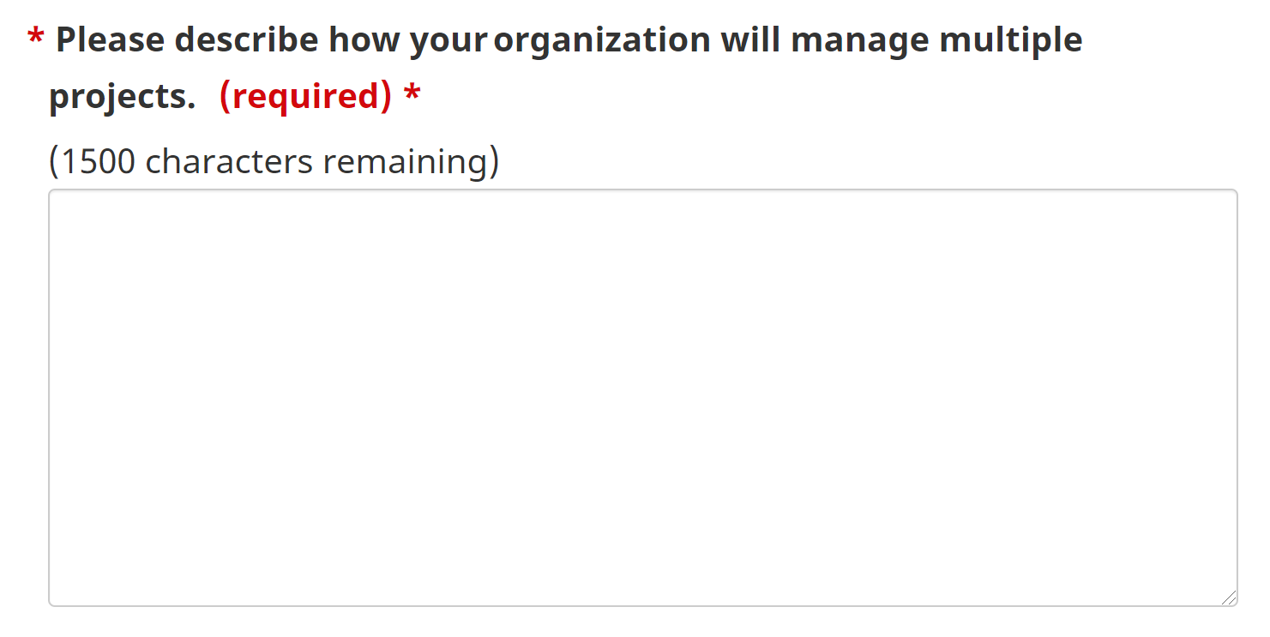

Enter your Project Title.

Enter your Project Description.

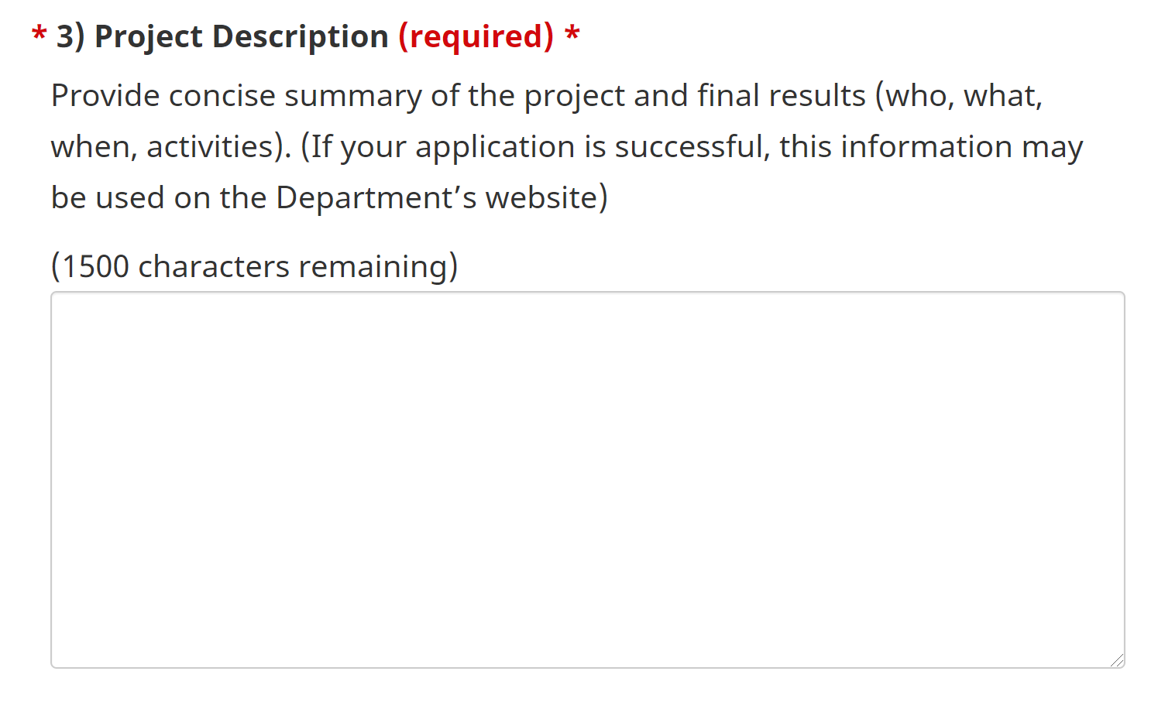

Indicate which of the following objectives your project addresses from the provided checklist.

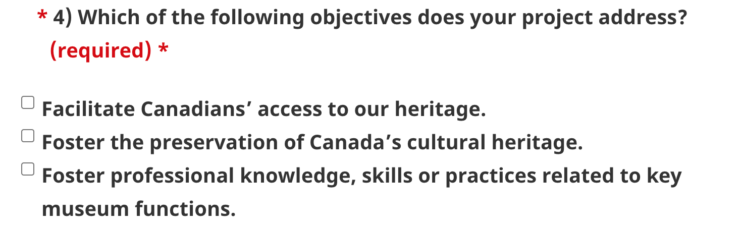

Describe how your project meets the objective(s) selected above.

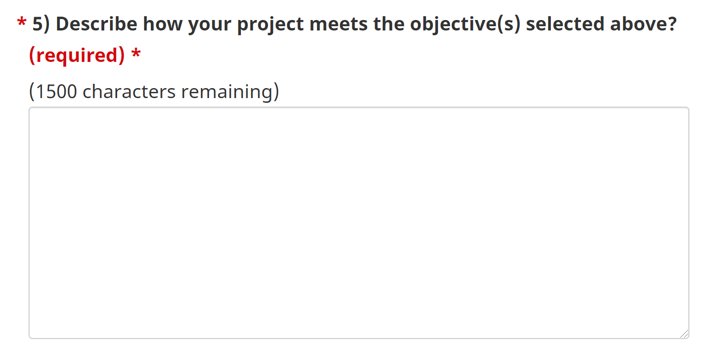

Click the green Save button at the bottom of the screen to save your progress.

If successful, once the page has refreshed, there will be a green Saved box at the top of the screen. Scroll down and click Next.

Official Languages

Choose either Yes or No from the dropdown menu if your organization belongs to an Official Language Minority Community. (Note: Anglophones in Quebec and Francophones outside Quebec)

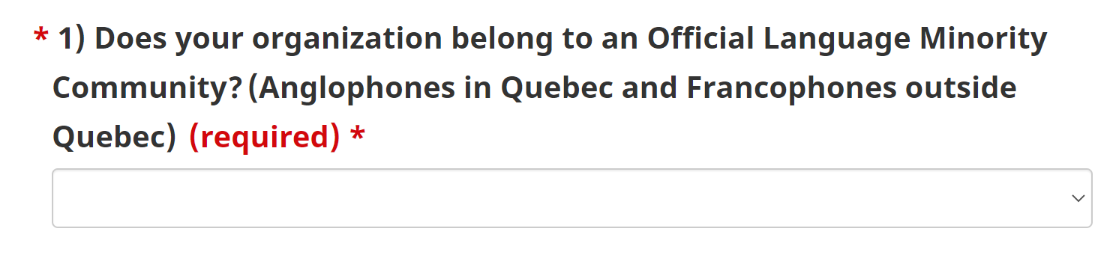

Choose either Yes or No from the dropdown menu if the project’s target audience or the communities involved in the project are composed of both English-speaking and French-speaking people.

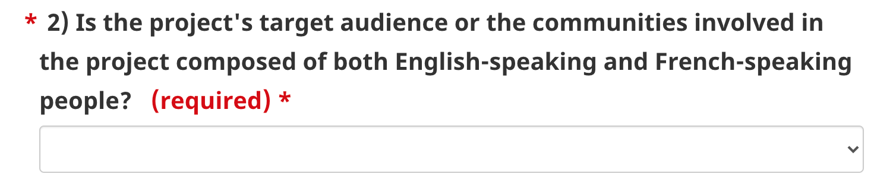

If Yes, please indicate what measures you will undertake to communicate with both groups to encourage each to participate in your project.

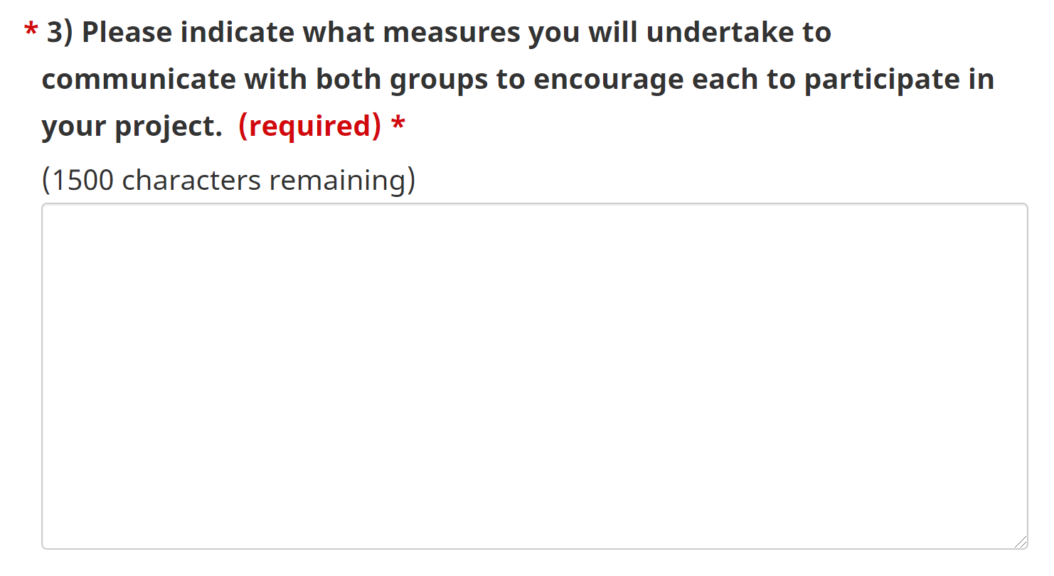

Choose either Yes or No from the dropdown menu if the project promotion and project-related information on your website will be posted in both English and French (webpages, social media, promotional materials, media kits, etc.).

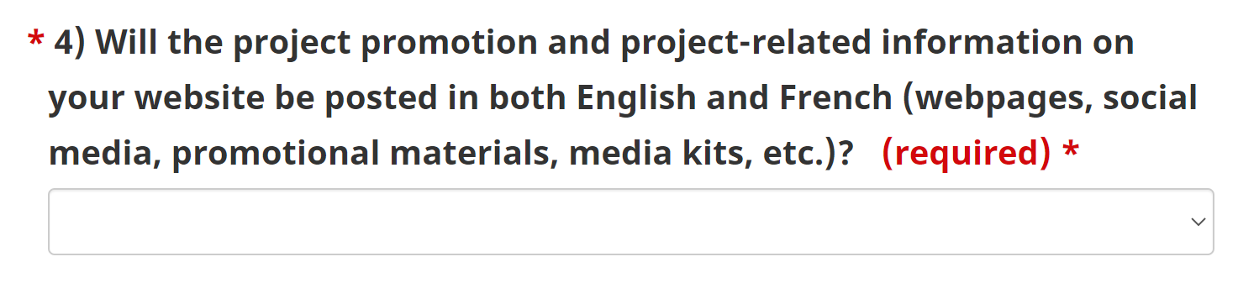

If Yes, please list where you will disseminate project-related promotion and information in both official languages. If No, please explain your answer.

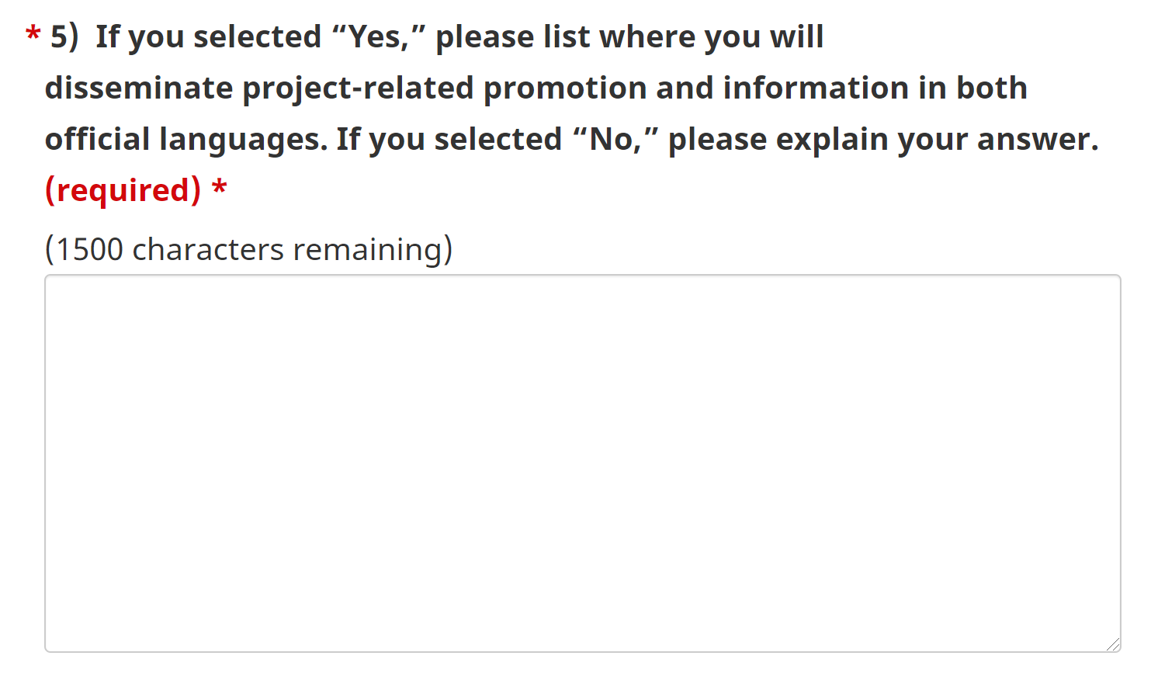

Choose either Yes or No from the dropdown menu if project-related products presented to the public will be in both French and English (educational materials, exhibition guides, programming materials, etc.).

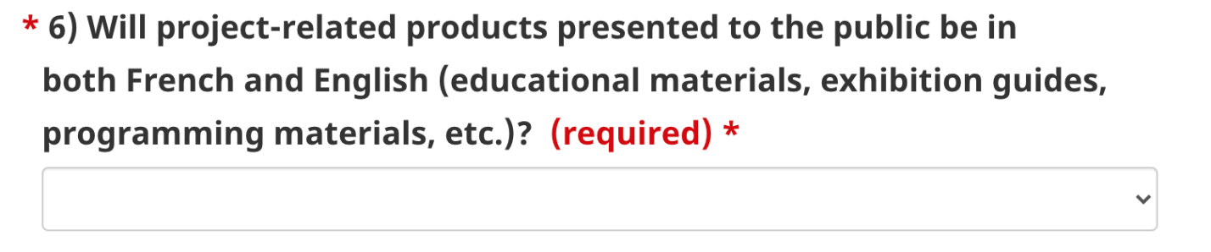

If Yes, please list the project-related products you will provide in both official languages. If No, please explain your answer.

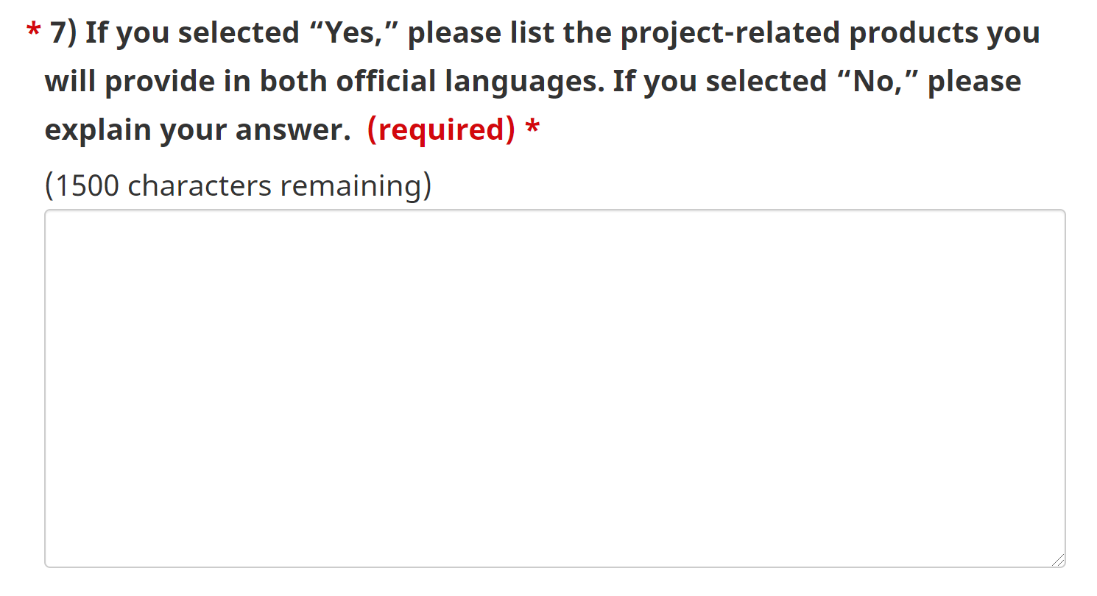

Click the green Save button at the bottom of the screen to save your progress.

If successful, once the page has refreshed, there will be a green Saved box at the top of the screen. Scroll down and click Next.

Community Engagement

If applicable, describe how your project engages/involves the community or other institutions and/or develops partnerships.

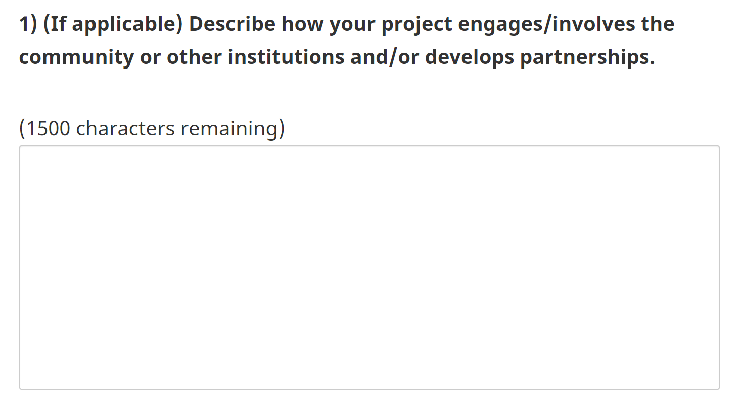

Choose either Yes or No from the dropdown menu if Indigenous communities are involved in the project or among the project’s target audience.

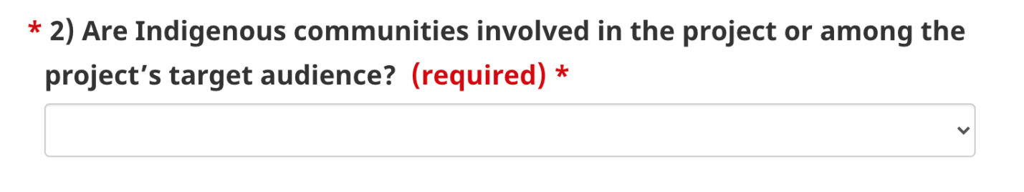

If Yes, please specify by selecting First Nations, Inuit, Métis, or Other (please specify).
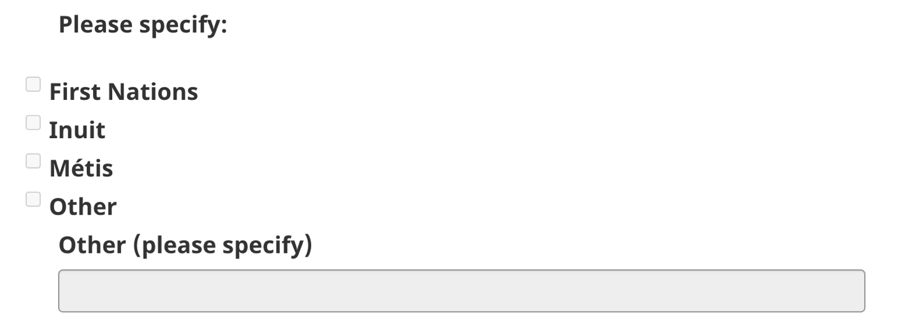

Choose either Yes or No from the dropdown menu if ethnocultural and/or racialized communities are involved in the project or among the project’s target audience. Definitions are listed below the question.

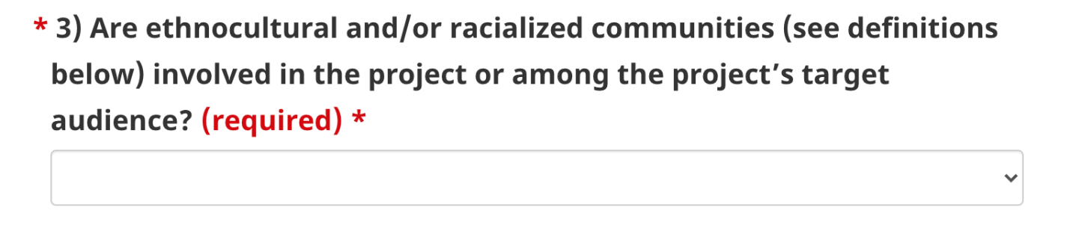

If Yes, please specify.

Choose either Yes or No from the dropdown menu if any other underserved communities (LGBTQ2+, youth, etc.) are involved in the project or among the project’s target audience.

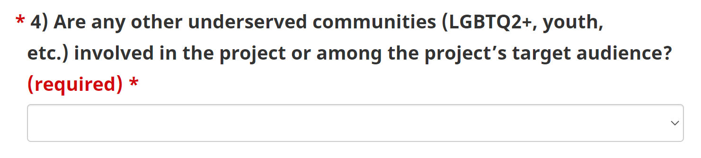

If Yes, please specify.

Choose Rural, Remote or N/A from the dropdown menu if the project’s target audience or the communities involved in the project are located in rural or remote areas.

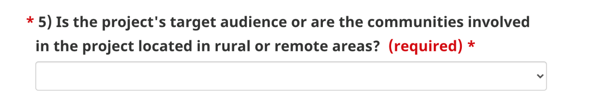

Click the green Save button at the bottom of the screen to save your progress.

If successful, once the page has refreshed, there will be a green Saved box at the top of the screen. Scroll down and click Next.

Project Planning

Enter the space requirements for the proposed exhibition in m² or ft² (e.g., 122 m²).

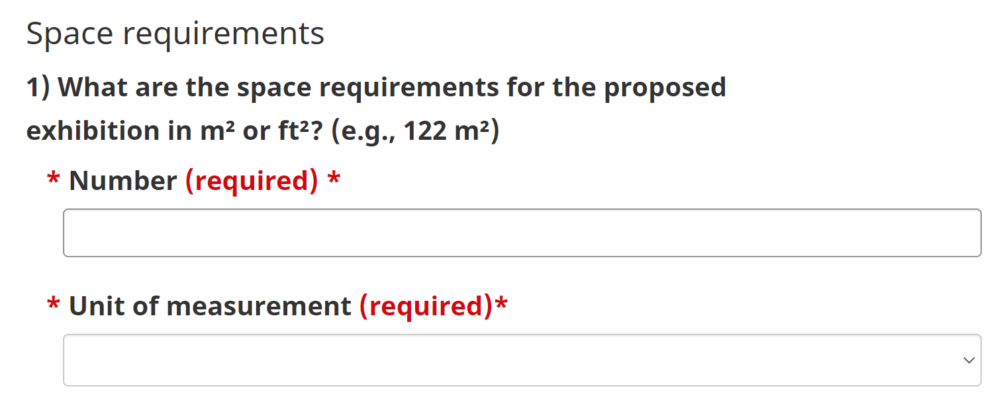

If the space requirement exceeds 186 m² (2,000 ft²), please specify how the potential for circulation has been taken into account.

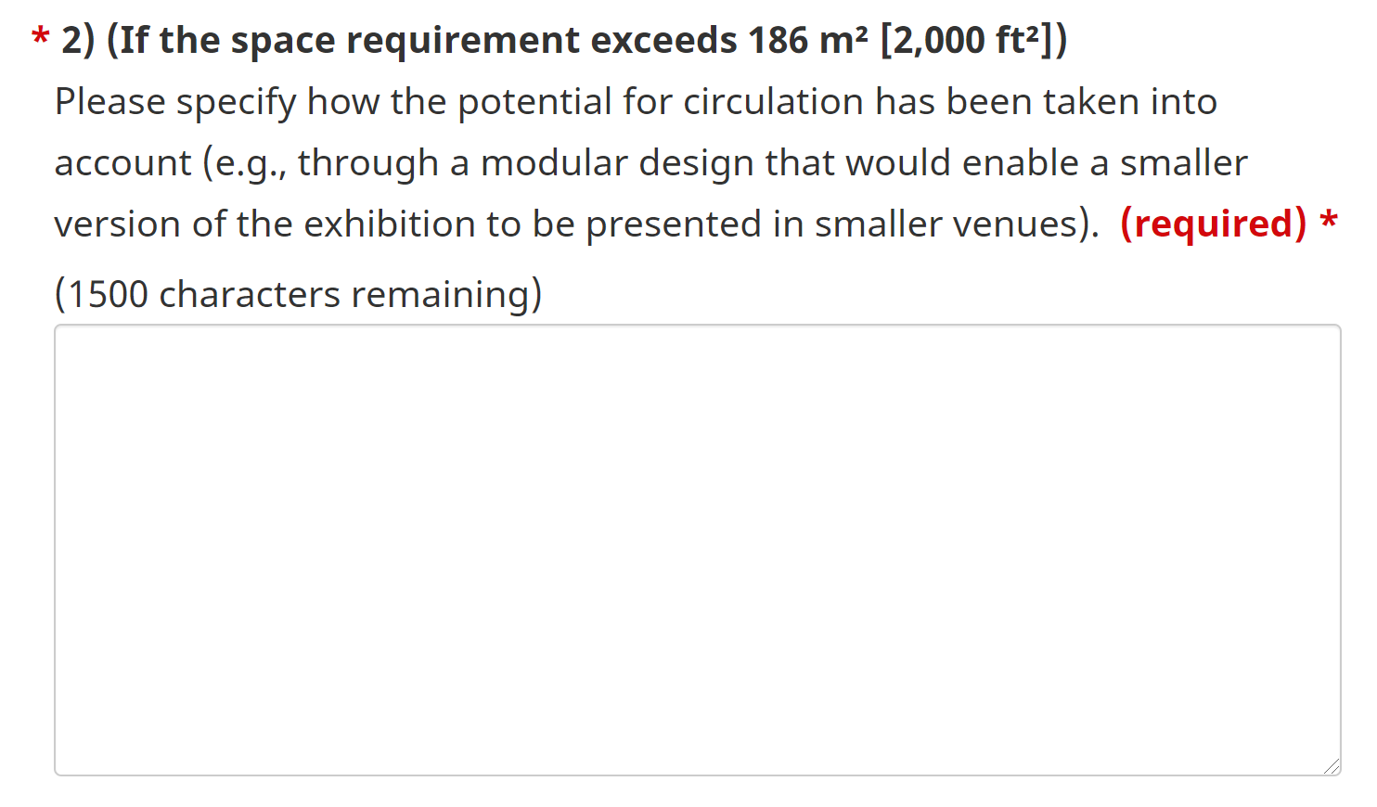

Enter the Project Start Date (MM/DD/YYYY).

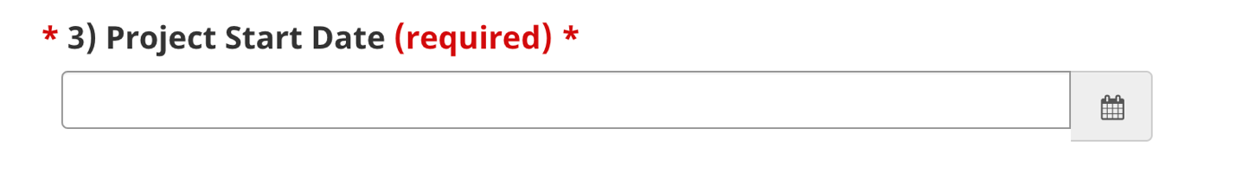

Enter the Project End Date (MM/DD/YYYY).

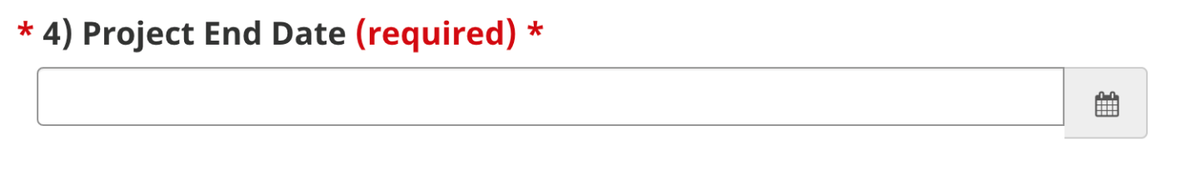

Enter the Total Cost of the Project.

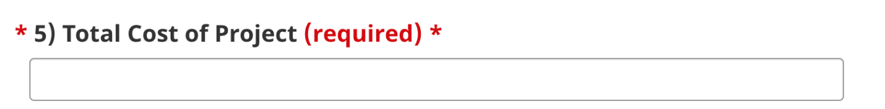

Enter the Total Funding Amount Requested from PCH.

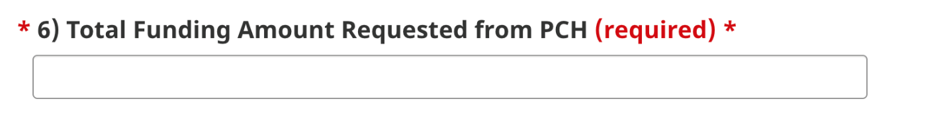

Click the green Save button at the bottom of the screen to save your progress.

If successful, once the page has refreshed, there will be a green Saved box at the top of the screen. Scroll down and click Next.

Project Detail
TIP: The page will not save your answers unless all text boxes are completed. If you would like to save this page before you’ve answered everything and return to it later, enter a single character (eg. “x”) in each box on the page and then click Save—this way, you will not lose the questions you have already answered. This tip applies to all pages.

Project Relevance
In the provided text box, describe how your organization will benefit from the results of the project, and why the project is important for your organization.

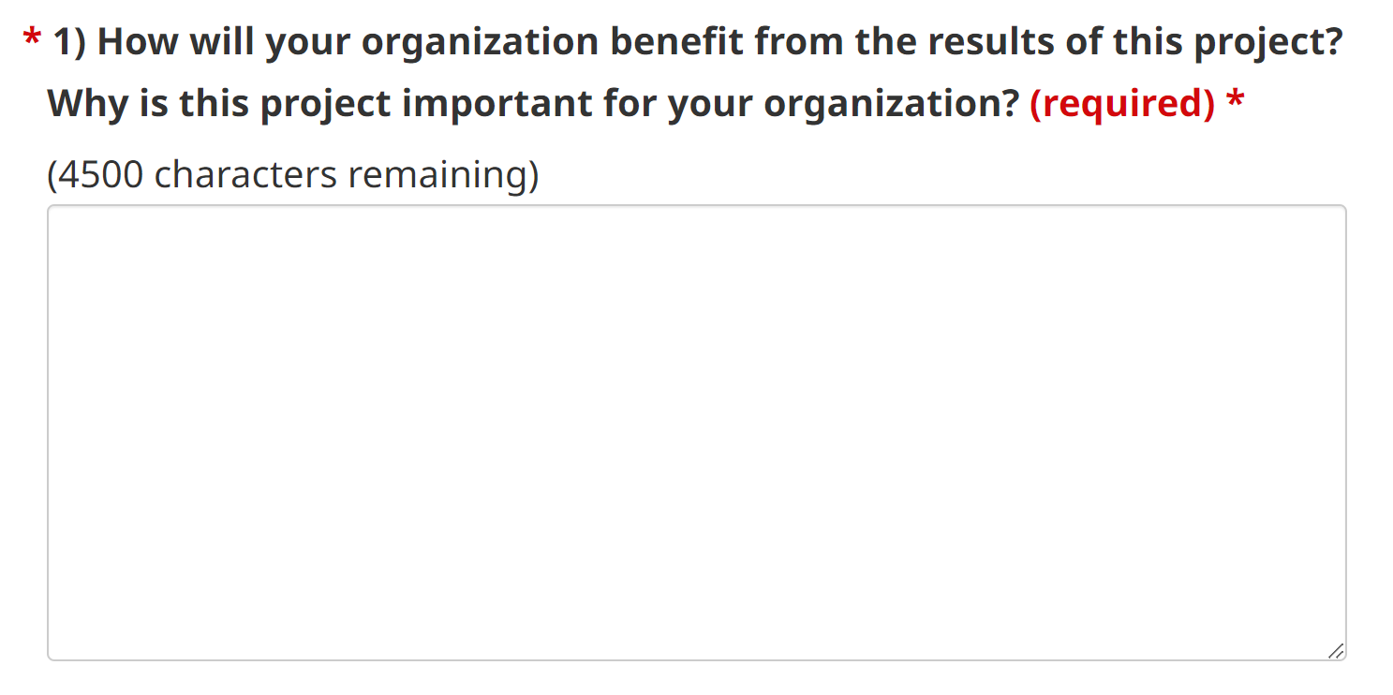

In the provided text box, describe who the final results are aimed at and the target audience.

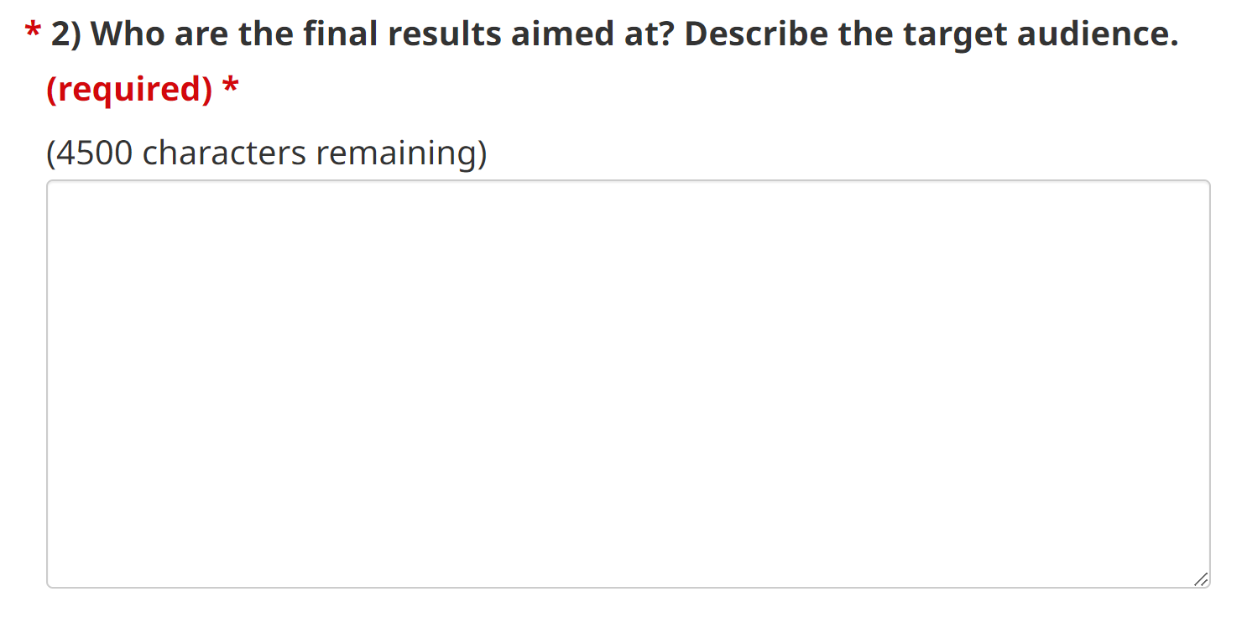

Project Planning, Management and Resources
In the provided text box, indicate the document title of the detailed timeline document attached in the “Supporting Documents” section. You can also provide any explanatory notes, if applicable.

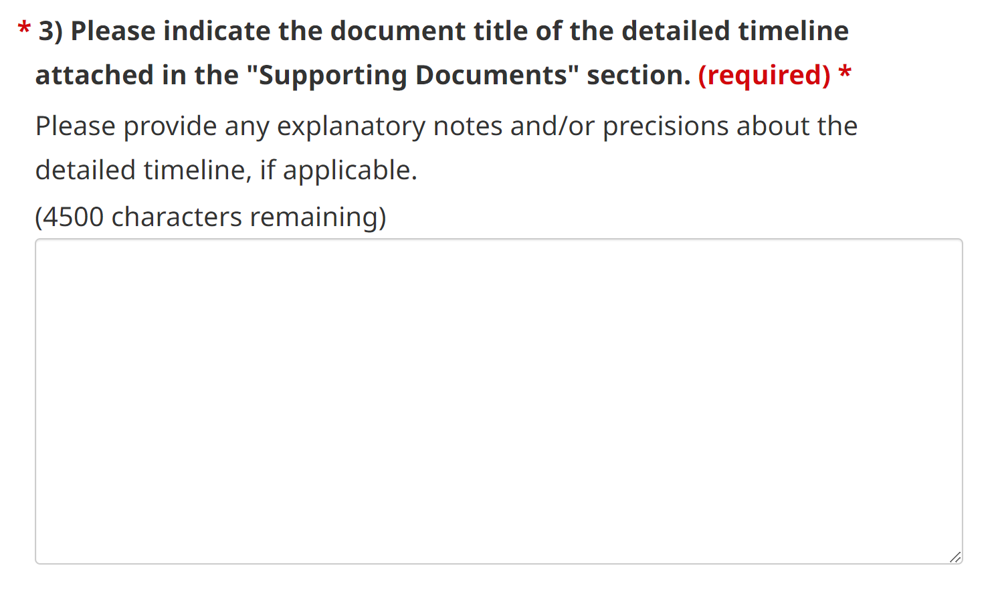

In the provided text box, describe the human and material resources for each activity.

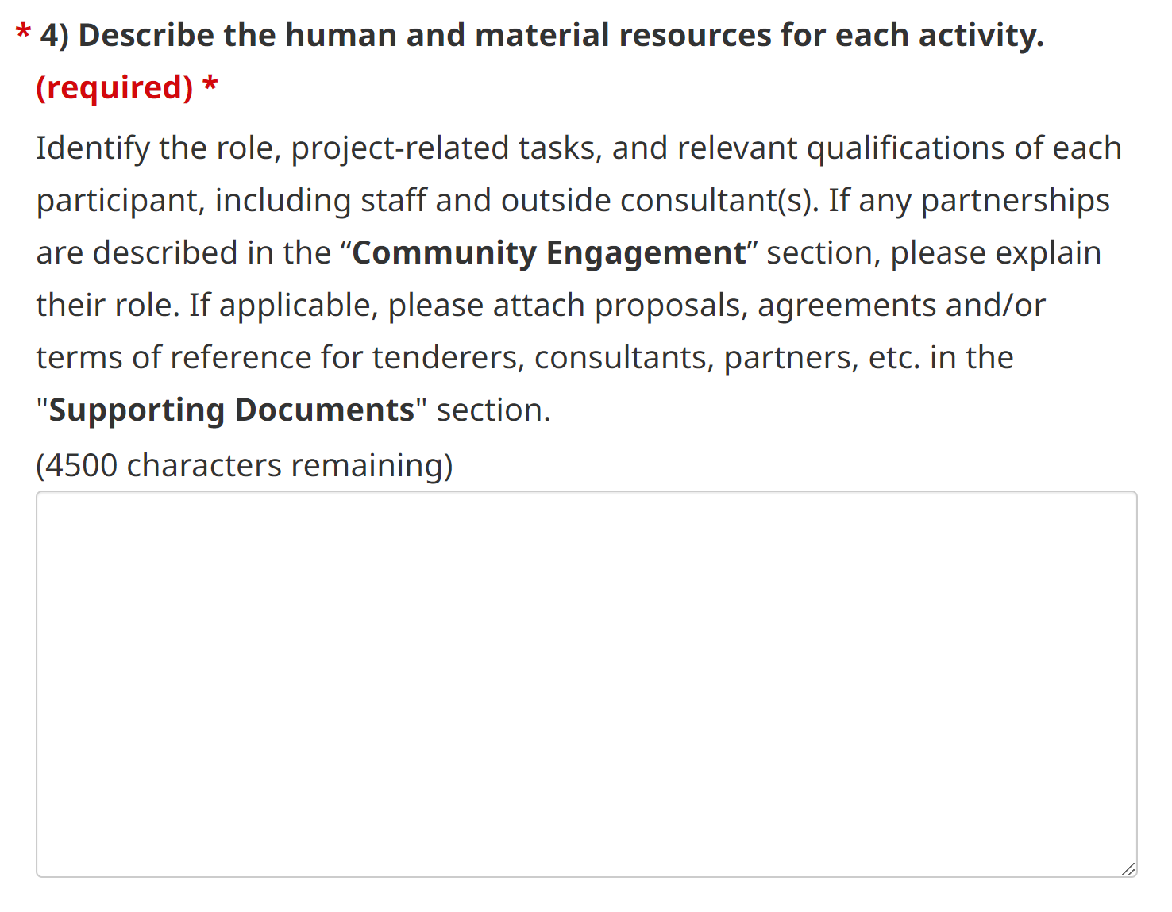

Expected Results and Project Evaluation
In the provided text box, indicate the document title of the detailed outline of your evaluation strategy attached in the "Supporting Documents" section.

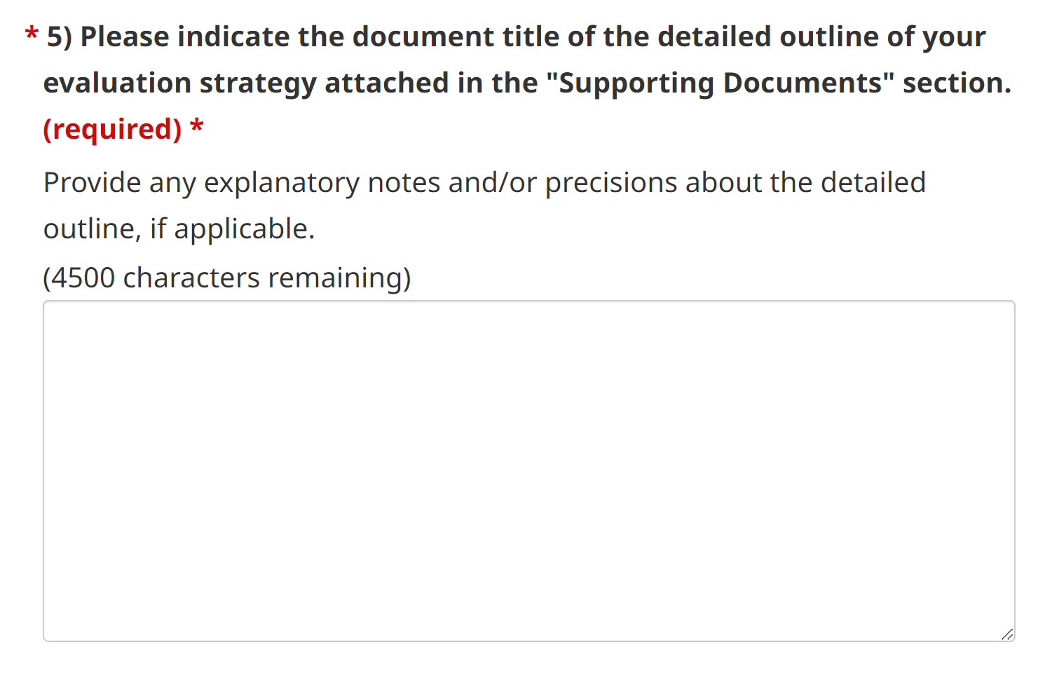

Click the green Save button at the bottom of the screen to save your progress.

If successful, once the page has refreshed, there will be a green Saved box at the top of the screen. Scroll down and click Next.

Project Budget

Click “Download the Project Budget Form here” to download the project budget form.
Once complete, click the Attach file button.

In the pop-up window, click the Choose File button to select your project budget file.

Click the green Attach File button at the bottom once finished.
If the file upload was successful, you will see the file name and date attached listed.

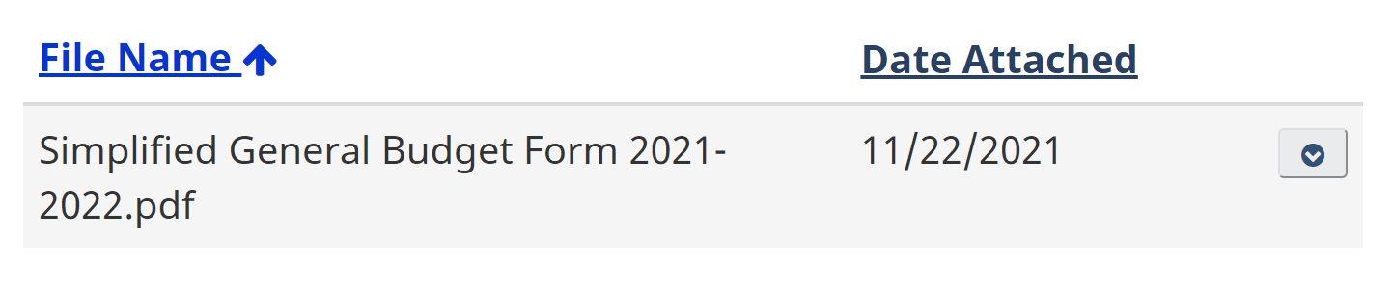

If necessary, provide any explanatory notes and/or precisions about the budget in the provided text box.

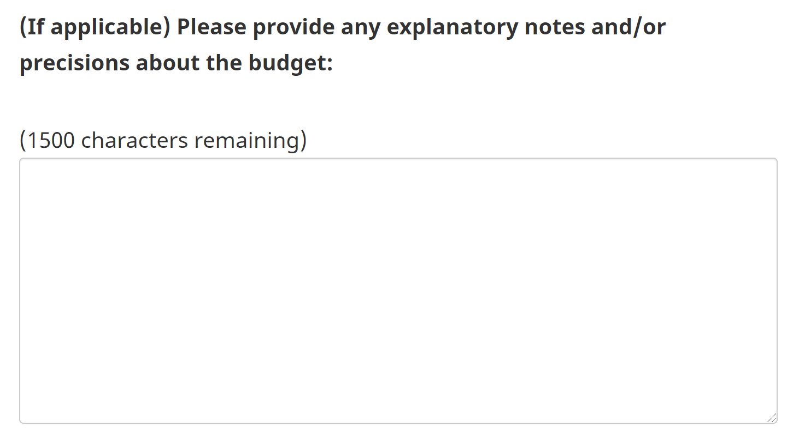

Click the green Save button at the bottom of the screen to save your progress.

If successful, once the page has refreshed, there will be a green Saved box at the top of the screen. Scroll down and click Next.

Organizational Capacity

Financial Stability
In the provided text box, please outline any significant changes since your last financial statement, if applicable.

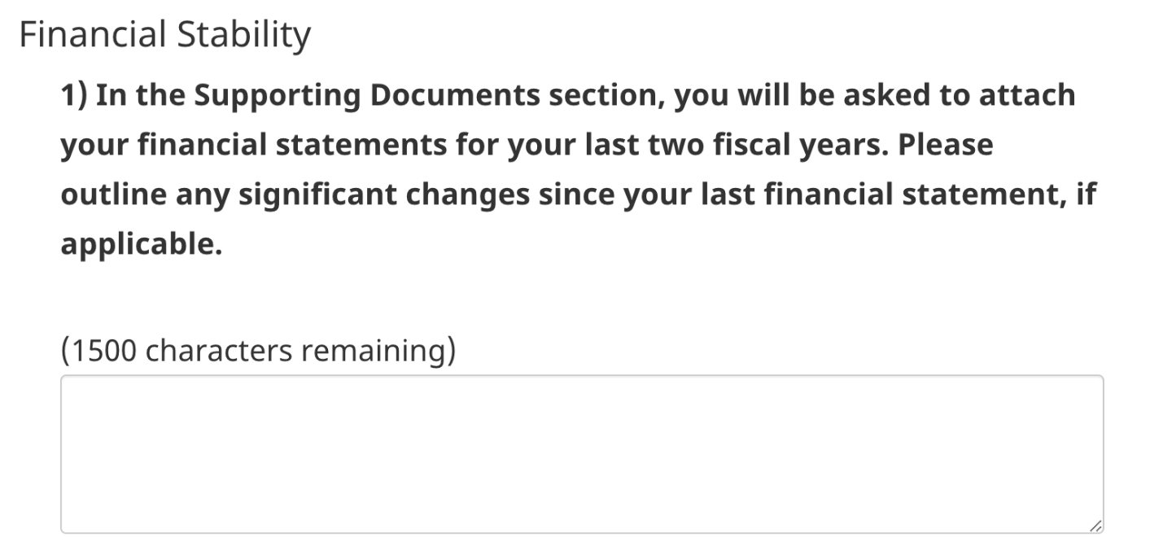

Governance Structure
In the provided text box, describe the role of the Board, Board Committees, and staff. Then, describe your key governance and operational policies.

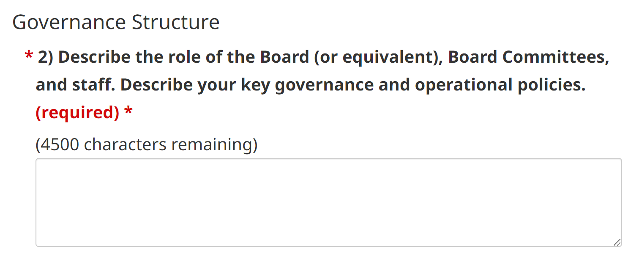

Mandate Implementation
In the provided text box, list your organization’s key museological activities and/or services. Then, describe your recent related accomplishments and how the activities relate to your mandate, and who are your clientele and community partners.

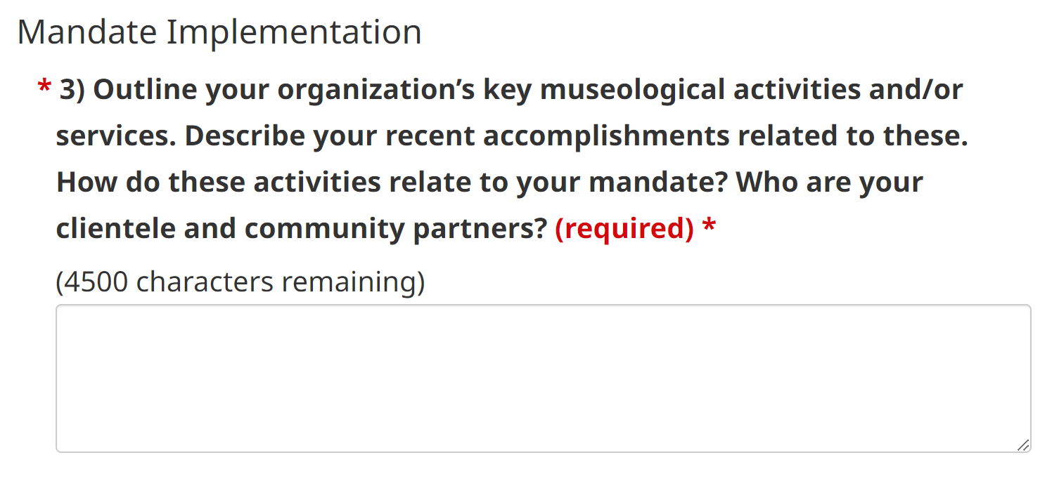

Click the green Save button at the bottom of the screen to save your progress.

If successful, once the page has refreshed, there will be a green Saved box at the top of the screen. Scroll down and click Next.

Supporting Documents

Please attach the following required supporting documents. Once you have completed an item in the list, check the corresponding box. Ensure that all documentation is current.

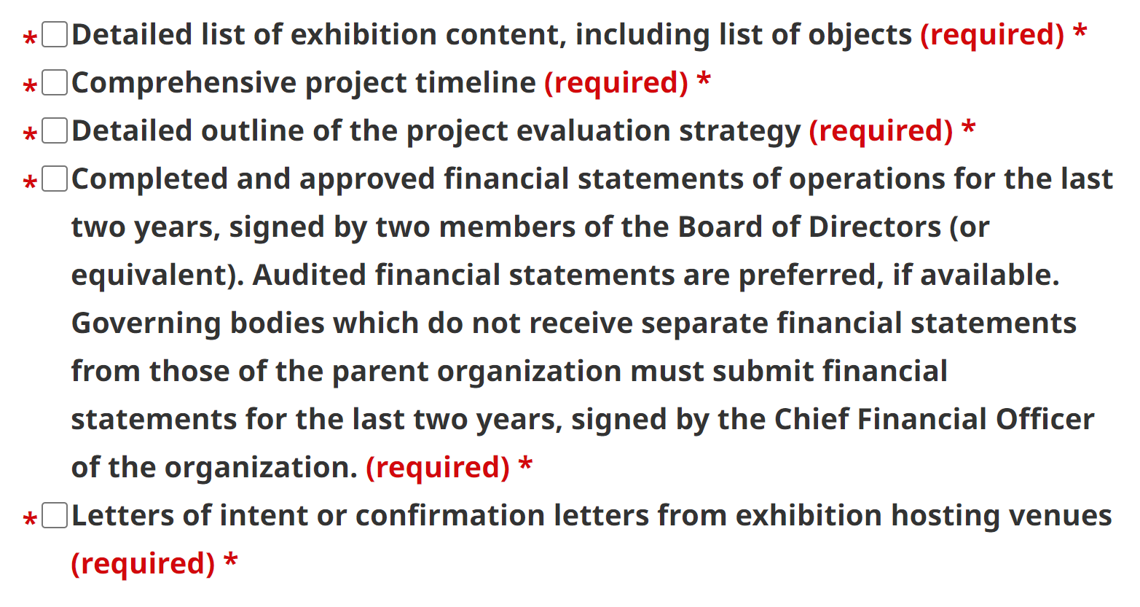
TIP: If all the required documents are included in one singular file, that one file can be attached and then all boxes can be checked off before proceeding.

To attach a file, click the Attach file button.

In the pop-up window, click the Choose File button to select your file.
Select your Document Type to specify what kind of file it is (Financial statements, Board members and staff, etc.).

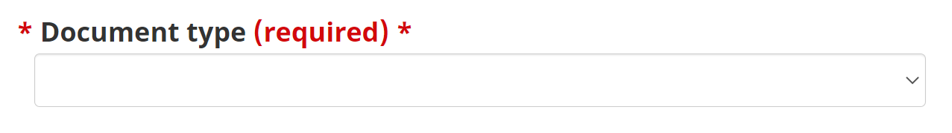

Click the green Attach File button at the bottom once finished.

If the file upload was successful, you will see the file name, document type and date attached listed.

Click the green Save button at the bottom of the screen to save your progress.

If successful, once the page has refreshed, there will be a green Saved box at the top of the screen. Scroll down and click Next.

Additional Documents

Please attach the following supporting documents if they apply to your project. Once you have completed an item in the list, check the corresponding box. Ensure that all documentation is current. If these documents are not relevant to your project, you are not required to click any boxes or save any files to this page. Please click Save to proceed to the next section.

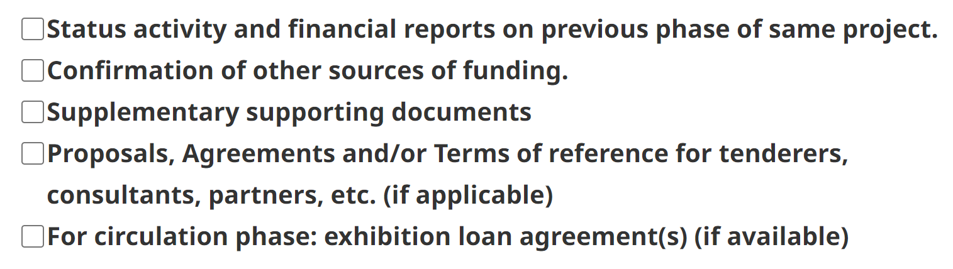

To attach a file, click the Attach file button.

In the pop-up window, click the Choose File button to select your file.

Select your Document Type to specify what kind of file it is (Status activity on previous phase, Other funding confirmation, etc.).

Click the green Attach File button at the bottom once finished.

If the file upload was successful, you will see the file name, document type and date attached listed.

Click the green Save button at the bottom of the screen to save your progress.

If successful, once the page has refreshed, there will be a green Saved box at the top of the screen. Scroll down and click Next.

Museum Requirements (*only for museums)

This section is only required for organizations that have identified themselves as a museum. If you need to change your organization type, return to the General Information section of the application and indicate your organization type as museum under Organization Type.

Please attach the following required supporting documents for museums. Once you have completed an item in the list, check the corresponding box.

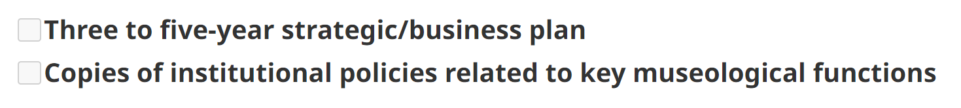

To attach a file, click the Attach file button.

In the pop-up window, click the Choose File button to select your file.

Select your Document Type to specify what kind of file it is (e.g. Three to five-year strategic/business plan, Copies of institutional policies, etc.)

Click the green Attach File button at the bottom once finished.

If the file upload was successful, you will see the file name, document type and date attached listed.

Click the green Save button at the bottom of the screen to save your progress.

If successful, once the page has refreshed, there will be a green Saved box at the top of the screen. Scroll down and click Next.

Declaration/Attestation

Please read the Declaration and Attestation sections in their entirety.

Once finished, check off the I agree box and the Name and Date fields will autocomplete based on your personal information and today’s date.

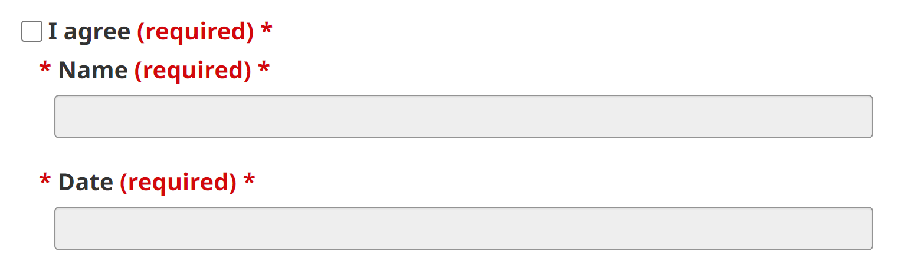

Final Review

Please make sure you have completed all the sections of the Application Form as you will not be able to submit the application with incomplete sections.

If you need to return to a section, either use the navigation menu on the left or the “Back” buttons. Once all the sections are complete, click “Submit.”

If some sections remain incomplete, you will receive an error message at the top of the section, prompting you to complete any outstanding questions.

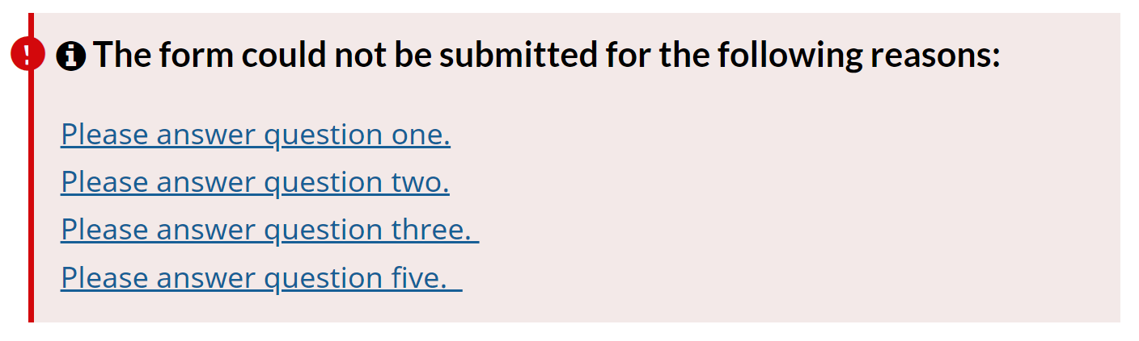

The list below will show each section and a status of either Complete or Incomplete.

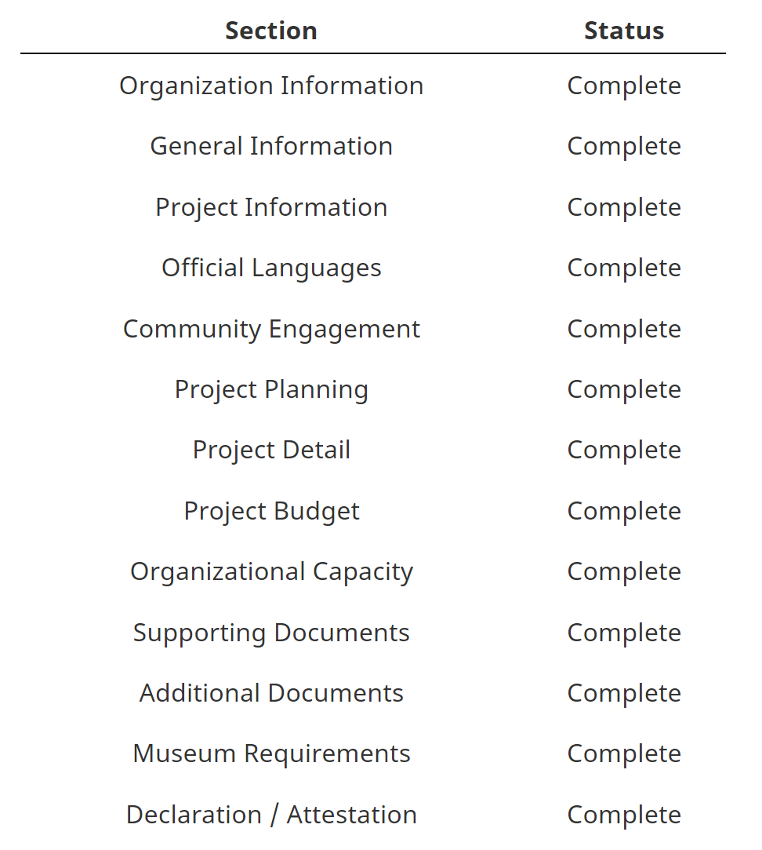

Printable Application
Once submitted, a printable PDF of your completed application and your Applicant Profile will be available here (it may take a few minutes to generate).

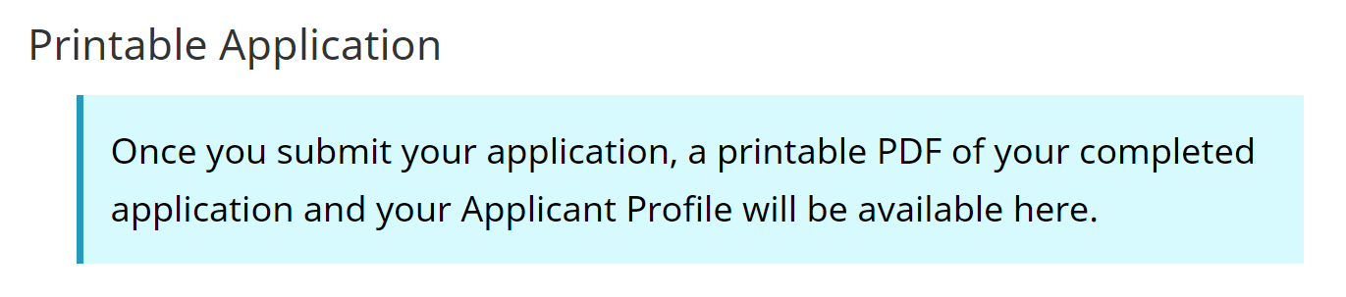
If all sections are complete, you will be able to click the green Submit button at the bottom of the page.

